

Imam Abdulrahman Bin Faisal University
College of Computer Science & Information Technology
Department of Computer Science

CS 411 – Software Engineering
Term 1 – 2024/2025

Software Design Specifications

For

[Mizan]

Version [2.0]

[Dr. -]

2025/05/10

This Software Design Specification was prepared and provided as a deliverable for [Course Name, number, term], and it will be used by [name of end user].
This document is based in part on the IEEE Recommended Practice for Software Design Descriptions.

[Team Members]

# | Name | ID | Role
1 | Mishal Al-jumaih | 2250030163 | Leader / Scrum Master
2 | - | - | UI Developer
3 | - | - | Programmer & DB Admin
Table 1- Group #4 Team Members

Table of Content

Revision History 5
Table of Tables 6
Table of Figures 7
1. Introduction 9
1.1 Purpose 9
1.2 Scope 9
1.3 Definitions, Acronyms, and Abbreviations 9
1.4 References 11
1.5 Document Summary 11
2. System overview 12
3. Design Considerations 13
3.1 Assumptions and Dependencies 13
3.2 General Constraints 13
4. User Interface Design 14
4.1 Overview of User Interface 14
4.2 Interface Design Rules 15
4.3 Screen Images & Screen Objects and Actions 16
4.4 Other Interfaces 28
4.4.1 Email (SMTP) Interface 28
4.4.2 Internal REST-like API Interface 28
4.4.3 File System Interface (Vault Module) 29
5. System Architecture 30
5.1 Architectural Design Approach 31
5.2 Architectural Design 32
5.3 Subsystem Architecture 34
5.3.1 Document Vault Subsystem 34
5.3.2 Project Sharing & Access Control Subsystem 35
5.3.3 Administrative Support & Ticketing Subsystem 36
5.3.4 Global Broadcast & Announcement Subsystem 37
5.3.5 Automated State Revocation Subsystem (Link Expiry) 38
5.3.6 Expense Processing & Budgeting Subsystem 39
5.3.7 Guest Authorization & Read-Only Presentation Subsystem 40
5.3.8 On-Demand Warranty Notification Subsystem 41
5.3.9 Administrative Lifecycle & Data Eradication Subsystem 42
5.3.10 User Feedback & Engagement Subsystem 43
5.3.11 Deep File Verification & Security Subsystem 44
6. Data Design 45
6.1 Data Description 45
6.2 Data Dictionary 46
6.3 Database Description 53
7. Component Design 56
7.1 Component Overview & Source Mapping 56
7.2 Component Algorithms (PDL / Pseudocode) 58
7.2.1Algorithm 1 — Process_Secure_File_Upload 58
7.2.2 Algorithm 2 — Scan_And_Notify_Expiring_Warranties [PDL] 59
7.2.3 Algorithm 3 — Generate_Secure_Share_Link [PSEUDOCODE] 60
7.2.4 Algorithm 4 — Check_Budget_Threshold [PDL] 61
8. Detailed System Design 62
8.1 Classification 62
8.2 Definition 62
8.3 Responsibilities 62
8.4 Constraints 62
8.5 Composition 63
8.6 Uses / Interactions 63
8.7 Resources 63
8.8 Processing 63
8.9 Interface / Exports 63
8.10 Detailed Subsystem Design 64
9. Other Design Features 65
9.1 Internationalization 65
9.2 Seamless Theming 65
9.3 Performance Design 65
9.4 Backup and Disaster Recovery 65
9.5 Accessibility (A11y) 65
10. Requirements Traceability Matrix 66

Revision History

Name | Date | Reason For Changes | Version
Mishal Al-jumaih | 29/04/2026 | Prepared initial SDS draft, system overview & architecture | 0.1
- | 01/05/2026 | Completed Data Design, DB schema mapping and Data Dictionary | 0.3
- | 03/05/2026 | Added UI Design section, screen descriptions, interface rules | 0.5
Mishal Al-jumaih | 05/05/2026 | Completed Component Design and Detailed System Design | 0.8
- | 07/05/2026 | Added Security design, RTM, and Other Design Features | 1.0
All Members | 10/05/2026 | Final review incorporating Dr. Saeed notes; v2.0 finalized | 2.0

Table of Tables

Table 1- Group #4 Team Members 2
Table 2 Users 46
Table 3 Projects 47
Table 4Expenses 47
Table 5 Warranties 48
Table 6 Invoices 48
Table 7 Files 49
Table 8Notifications 49
Table 9 Password_resets 50
Table 10Login_attempt 50
Table 11Project_share 50
Table 12Activity_logs 51
Table 13Support_tickets 51
Table 14Announcements 52
Table 15 ticket_replies 52
Table 16 (14 database tables) 54
Table 17 Component Overview & Source Mapping 57
Table 18 Local Data: Algorithm 1 — Process_Secure_File_Upload 58
Table 19 Local Data: Algorithm 2 — Scan_And_Notify_Expiring_Warranties [PDL] 60
Table 20Local Data: Algorithm 3 — Generate_Secure_Share_Link [PSEUDOCODE] 60
Table 21Local Data: Algorithm 4 — Check_Budget_Threshold [PDL] 61

Table of Figures
Figure 1 Welcome Screen (welcome.php) 15
Figure 2 Sign-In Screen (login.php) 15
Figure 3 Sign-Up Screen (register.php) 16
Figure 4 :Dashboard (index.php) 16
Figure 5 Projects Screen (pages/projects.php) 17
Figure 6 New Project (crate) 17
Figure 7Project Detail (pages/project-detail.php) 18
Figure 8 New Expanse 18
Figure 9 Update project status 19
Figure 10Vault Screen (pages/files.php) 19
Figure 11 Upload files 20
Figure 12 Reports Screen (pages/reports.php) 21
Figure 13Settings Screen (pages/settings.php) 21
Figure 14Public Share Screen (share.php) 22
Figure 15admin_login.php 22
Figure 16admin/dashboard.php 23
Figure 17admin/dashboard.php.2 23
Figure 18 login_page.php — Low-Fidelity Wireframe 24
Figure 19 logout_confirmation.php — Low-Fidelity Wireframe 24
Figure 20account/signup.php — Low-Fidelity Wireframe 25
Figure 21settings/profile.php — Low-Fidelity Wireframe 25
Figure 22 home.php — Low-Fidelity Wireframe 26
Figure 23Use Case Diagram 29
Figure 24Overall 3-Tier MVC System Architecture of Mizan 30
Figure 25Sequence Diagram 1 Upload Vault Document 34
Figure 26 Sequence Diagram 2 Generate Share Link 35
Figure 27 Sequence Diagram 3 Resolve Support Ticket 36
Figure 28 Sequence 4 Dispatch Broadcast Announcement 37
Figure 29 Sequence Diagram 5 Automate Link Expiry Revocation 38
Figure 30Activity 1: Add Expense & Budget Validation 39
Figure 31 Activity 2: View Shared Project 40
Figure 32Activity 3: Scan Warranty Expiry (Automated) 41
Figure 33Activity 4: Process User Account Deletion 42
Figure 34Activity 5: Handle Platform Feedback Submission 43
Figure 35Activity 6: Verify File Security via MIME Type 44
Figure 36 ERD Diagram 55

Introduction

Purpose
The Software Design Specification (SDS) is an extensive documentation detailing the design of Mizan software to help in management and archiving of personal finances over time. It is technical documentation based on the Software Requirement Specifications (SRS) and includes design of the systems, databases, component responsibility, UI design, security, among others.
Intended Audience:
This report mainly targets the developers of the software (both frontend and backend developers), database managers, software testers involved in the project named Mizan. Also, the architecture report is for the evaluation by the academic evaluators and supervisors for checking whether the structure of the system meets IEEE standards.

Scope
This scope of the Software Design Document covers the entire architecture design of the Mizan system, including its 3-tier MVC architecture, REST API endpoints, MySQL relational database design, and front-end UI design. The scope does not cover the physical deployment architecture, which will be covered in a separate DevOps manual.

Definitions, Acronyms, and Abbreviations
Term | Definition
Mizan | The name of the personal finance management system being designed, translating to "balance" in Arabic.
SDS | Software Design Specification - this document, describing how the Mizan system is structured and implemented.
SRS | Software Requirements Specification. The companion document outlining the functional and non-functional requirements.
SPMP | Software Project Management Plan. The planning and scheduling document for the project.
PDO | PHP Data Objects. A database access layer providing a uniform method of access to multiple databases.
REST-like API | Application Programming Interface following REST architectural constraints for client-server communication.
CSRF | Cross-Site Request Forgery. A web security vulnerability that tricks users into submitting unintended requests.
XSS | Cross-Site Scripting. A vulnerability allowing the injection of malicious scripts into web pages viewed by other users.
CSPRNG | Cryptographically Secure Pseudo-Random Number Generator. An algorithm used to generate unpredictable random numbers for security tokens.
rafThrottle | A custom JavaScript performance utility utilizing requestAnimationFrame to optimize high-frequency DOM events.
mizanFetch | A custom JavaScript wrapper for the Fetch API used to handle and standardize system-wide HTTP requests.
Double-Submit Guard | A UI safety mechanism that disables a submit button on first click (btn.disabled=true) to prevent duplicate DB insertions. Re-enabled on API response.
WCAG 2.1 | Web Content Accessibility Guidelines version 2.1. An international standard for web content accessibility.
RTM | Requirements Traceability Matrix. A table mapping SRS requirements to SDS design components.
SoC | Separation of Concerns. A fundamental design principle for separating a program into distinct sections, each addressing a separate concern.
Vault | The designated digital storage module within Mizan for financial documents, invoices, and contracts.
Nature | A classification attribute for Mizan projects, categorized as either Personal or Commercial.
DECIMAL(12,2) | A fixed-point numeric data type in MySQL used for storing precise monetary values without floating-point rounding errors.

References
•IEEE Std 1016-1998 - Recommended Practice for Software Design Descriptions.
•BCS 202 - Software Engineering course materials, Imam Abdulrahman Bin Faisal University.
•Mizan SRS v2.0 (26/04/2026) - companion requirements specification.
•Mizan SPMP v2.0 (18/03/2026) - Software Project Management Plan.
• Mizan Status Report 1/2
•W3C WCAG 2.1 - Web Content Accessibility Guidelines, Level AA.
•PHP 8.x Documentation - https://www.php.net/docs.php
•MySQL 8.x Reference Manual - https://dev.mysql.com/doc/
•Chart.js v4 Documentation - https://www.chartjs.org/docs/

1.5 Document Summary
- The Software Design Specification (SDS) will be structured in such a way that it gives a top-down perspective on the Mizan system.
- The second section will give a system overview.
- The third and fourth sections contain design constraints and interface guidelines respectively. The fifth section will cover high-level 3-tier MVC architecture.
- The sixth section will give complete database design and dictionary.
- Lastly, the eight and tenth sections cover algorithms/processing in each subsystem and trace them to SRS respectively.

System overview
Mizan is an all-inclusive, web-based personal and business finance manager that follows a 3-layer MVC architectural design. The system runs on a strong stack similar to LAMP (Apache/MySQL/PHP), which is purely server side and requires no client installation and can be accessed from any web browser.
The primary functions of the system are related to five spheres:

- Projects and Dashboard: Critical financial tools for monitoring budgets and workflow.

- Expenses: Advanced high-resolution components for expenses tracking based on DECIMAL (12,2).

- Vault Module: Efficient documents storage system that supports up to 500 MB invoices, guarantee, and contract upload.

- Reports: Comprehensive data visualization engine based on the Chart.js library that provides export options to PDF/CSV formats.

- Notifications: Automatic reminders via the user interface and e-mail messages on expiration of the guaranteed term or exceeding the budget limit.

The Presentation Layer is dynamically rendered using HTML5, CSS variables. That ensures smooth performance on all available browsers and devices. The system provides translation into two languages The UI layer supports dynamic bi-directional localization (RTL/LTR) and switching between light and dark themes with CSS variables. It automatically generates financial data on business and personal project incomes and expenses depending on user preferences. Moreover, the platform implements robust security mechanisms to mitigate common web vulnerabilities such as XSS, SQL Injection, and CSRF. Project sharing occurs via CSPNG-based read-only links.

Design Considerations

Assumptions and Dependencies
The target deployment environment is a standard LAMP/WAMP stack supporting PHP 8.x and MySQL 8.x.
•PHP INI: upload_max_filesize and post_max_size must be at least 500 MB.
•SMTP server configured in config/mail.php for password reset and warranty notification emails.
•Database mizan_db created with all tables from database.sql (including all ALTER TABLE additions).
•Tailwind CSS compiled locally via npm/PostCSS; production output is assets/css/style.css.
•Chart.js v4 loaded from CDN or bundled assets. No server-side chart rendering required.
•Users have modern browsers (Chrome 100+, Firefox 100+, Safari 15+, Edge 100+) with JavaScript enabled.

General Constraints

The system design is bounded by the following architectural and environmental constraints:
- Single-machine design. The web server, application logic, and database run on the same machine, allowing easier integration within an academic environment.

- 100% Prepared Statements Restriction. Every SQL query that is used should utilize PDO prepared statements and specified parameters. The value of PDO: ATTR_EMULATE_PREPARES is set to false. SQL strings cannot be interpolated in the system architecture – this is a design requirement, not an optional feature.
- Timeout for an idle session is set to 900 seconds (15 min). Idle sessions will be terminated to avoid risks associated with financial data access from a shared computer.
- Inner HTML usage is restricted. No user-entered HTML will be added to any element using inner HTML or insertAdjacentHTML function. Only dynamic DOM construction through creates Element() and setting text content will be allowed.
- Financial Accuracy Restrictions: Every financial datum should be stored with the help of the DECIMAL (12,2) data type – never FLOAT nor DOUBLE. These floating-point types are based on binary data and cannot represent decimal values correctly.
- Only local file systems can be used for storing files (uploads/ folders), there is no cloud file storage.
- Notifications are retrieved when user opens the notification panel.
- The maximum size for one file is 500 MB – limited both by the EXT_TO_MIME function logic and PHP server configuration.

User Interface Design

Overview of User Interface

- User Interface & Visual Language Design: In the Mizan user interface there is a fixed design for sidebars.
- On logging in, the sidebars do not hide and contain the following navigation links: Dashboard, Projects, Files/Vault, Reports, Settings, and Support Center.
At the top, you will find the username and an alerts badge, which shows the number of unread messages once in 60 seconds.
- The Mizan design visual language relies on a combination of dark blue base surfaces (1B3A6B), frosted glass cards with a blurred background and teal accents (0D7377) for call-to-action elements. The value of all colors is defined using custom CSS properties and switched using the data-theme attribute in the <main> element.
- User-Friendly Ease of Use: As far as the user experience is concerned, all interactions with the system to perform the required actions The interactions are optimized for minimal click-depth and rapid data entry.
- Financial Tracking: The interaction with the system takes place through the Projects module. There, users can set up customized workspaces to track expenses using pop-ups with accurate expense categories and amounts.
- Document Management: When accessing "Files/ Vault" one can drag-and-drop the invoices, contracts, and guarantees (large files up to 500 MB in size). The uploading is performed in the background, which makes the user interface work fast and efficiently.
- Analytics and Export: In "Reports" view one finds dynamic Chart.js panels, which show the spending trends. Using the dedicated buttons, it is possible to export the report as CSV and PDF files to get instant access to one's financial statistics.

- Feedback and Information Display: To ensure a clear understanding and confirmation of each step within the system, the user is provided with consistent feedback:
- Action Confirmation: All successful actions in the application lead to a neat SweetAlert2 pop-up window that confirms each task's successful completion.
- Data Validation: In case the user inputs incorrect data into the form, he/she immediately receives a warning message about the fields requiring modification before the submission.
- System Alerts: The bell at the top alerts users to some events (e.g. warranty expiration – 30 days, 7 days, or expiration notification). As well as color-coded badges at the tables/cards' statuses, such as the green color of active status and red color of the expired one.

Interface Design Rules
- Localization and Direction (Right-to-Left/Left-to-Right): The layout direction (the dir property in the `<html>` tag) is dynamically switched based on the authenticated user language preference (Arabic = right-to-left, English = left-to-right). The user interface relies on the Tailwind CSS rtl variables to handle logical layout reversal without the need for redundant and duplicate stylesheets.

- Performance Improvement (60 FPS Target): To ensure smooth user interactions, all Chart.js redraws, scroll event listeners, and intensive DOM refresh calls are encapsulated in a dedicated control function (window.mzRafThrottle). This aligns the implementation with the browser's compiler framework (approximately 16.7 ms), ensuring that visual updates to the main thread are not blocked. (See: assets/js/main.js)

- Strict DOM Handling (Preventing XSS): User-inputted content via `innerHTML` or `insertAdjacentHTML` is prevented by design. All dynamic DOM elements must be systematically created using `document.createElement()` and `textContent`. This rule at design time completely eliminates the vulnerability to client-side cross-site scripting (XSS) attacks.

- Dynamic Theme Engine (CSS Variables): The light/dark theme toggle works by setting the `data-theme` attribute to the root element, instantly switching custom CSS properties (such as `--bg-primary`, `--text-main`, and `--accent`). This ensures that the page does not reload. Furthermore, Chart.js instances listen for the custom `mizan:theme-change` event to dynamically redraw the panels with accurate theme colors.

- Secure Asynchronous Communication (CSRF Protection): All state-changing AJAX operations (POST/PUT/DELETE) must use the custom `mizanFetch()` wrapper. This function automatically extracts the X-CSRF-Token from the `<meta>` tag and inserts it into the request headers. Bypassing this wrapper to directly use the fetch() function is strictly prohibited.

- Duplicate and State Protection (Double-Submission Protection): Each form submit button is proactively disabled upon its first click and remains disabled until the API returns a response. This prevents data collisions and duplicate entries in the database due to double-clicks by the user or late-response network connections.

- Responsive and Flexible Grid: The user interface utilizes Tailwind CSS Flexbox and CSS Grid modules designed with a mobile-first approach. Complex designs automatically and seamlessly transform into user-friendly, single-column interfaces for mobile screens (below 640p).

Screen Images & Screen Objects and Actions
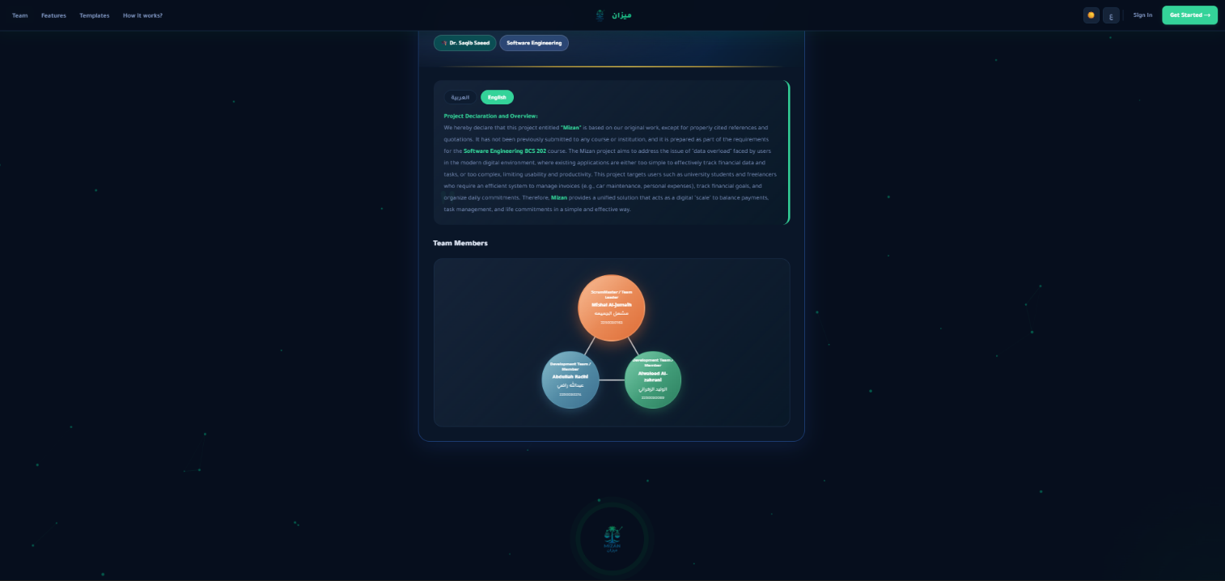
Figure 1 Welcome Screen (welcome.php)

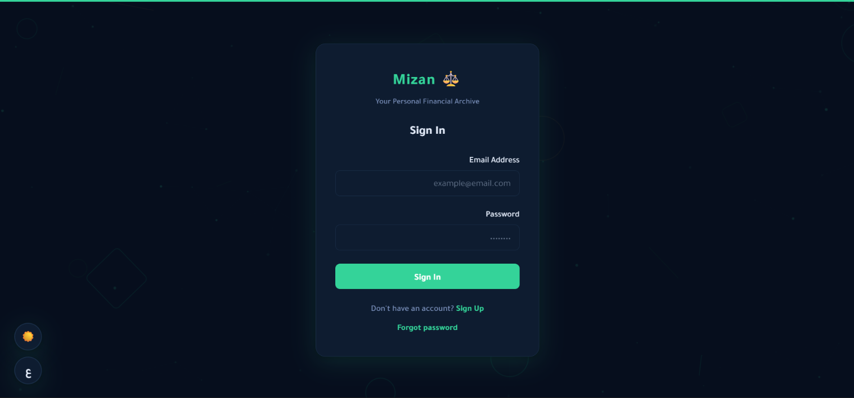
Figure 2 Sign-In Screen (login.php)

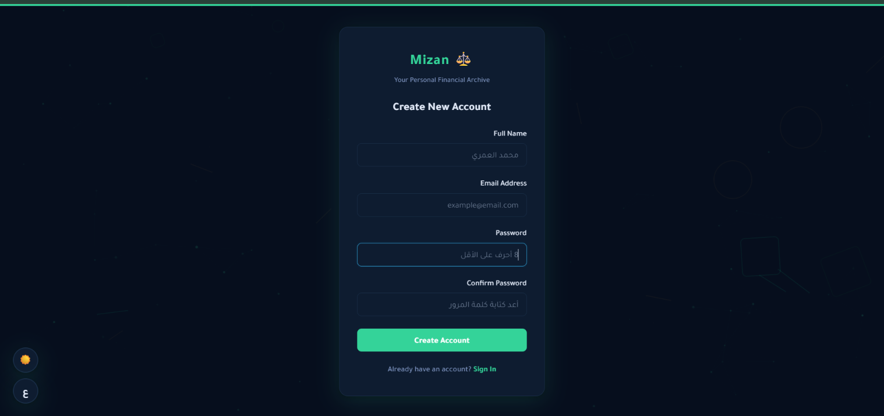
Figure 3 Sign-Up Screen (register.php)
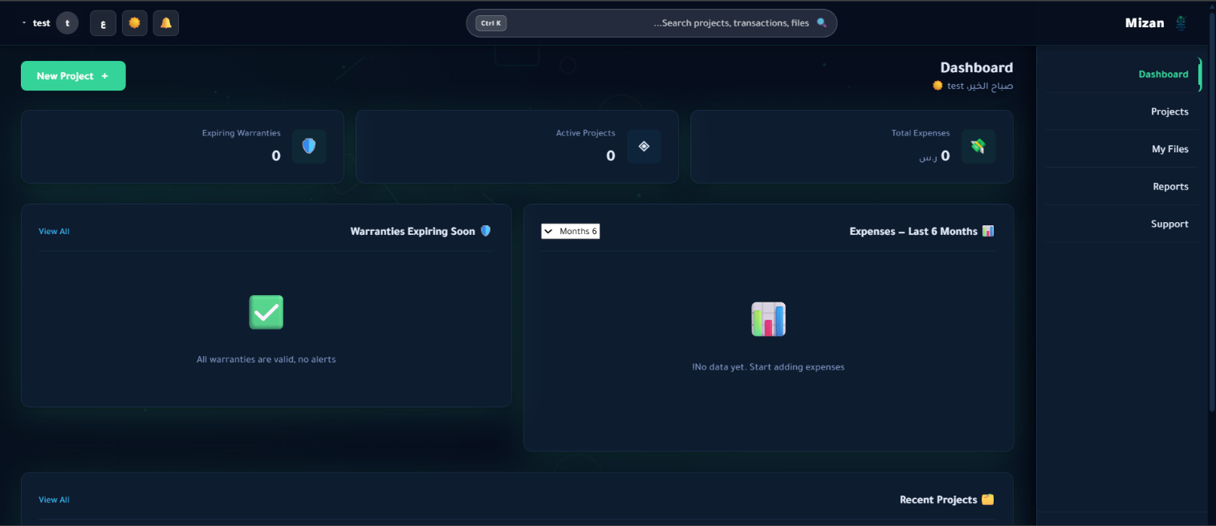
Figure 4 :Dashboard (index.php)
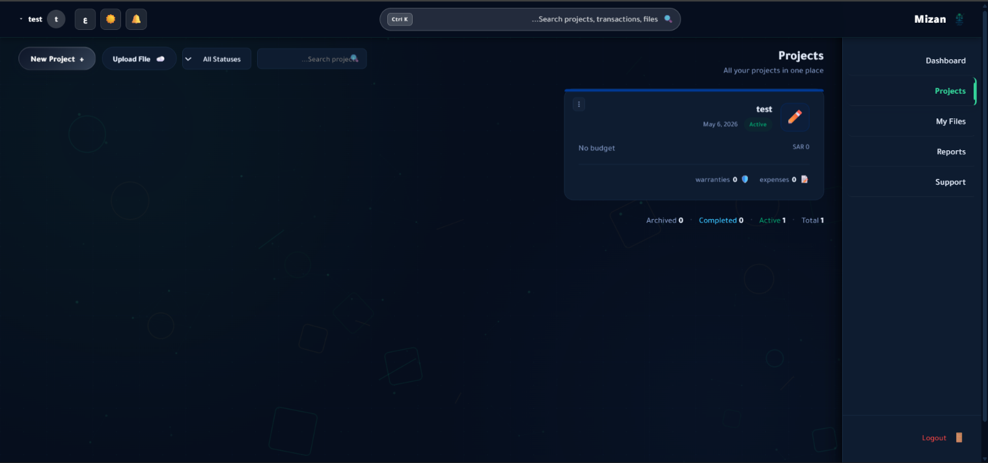
Figure 5 Projects Screen (pages/projects.php)
"Create Project" Button (Object): Click (Action) -> Triggers the "New Project" modal/pop-up window.
Status Badges (Object): Visual indicator only. Dynamically assigned CSS classes (green/red) based on project temporal state.
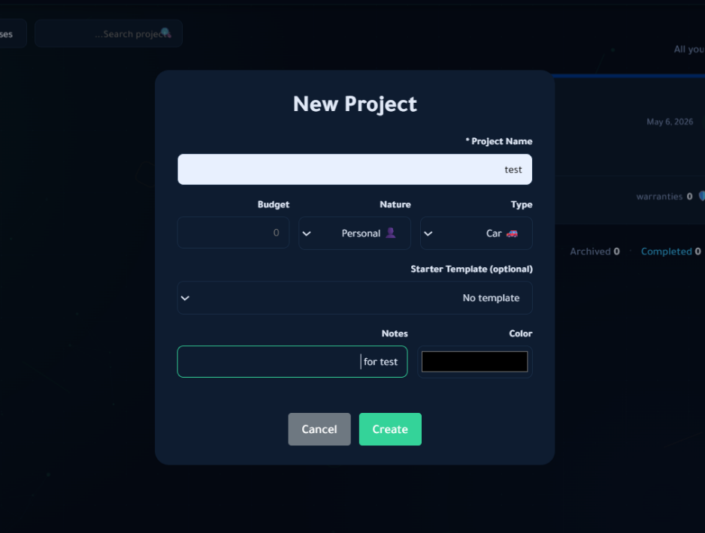
Figure 6 New Project (crate)
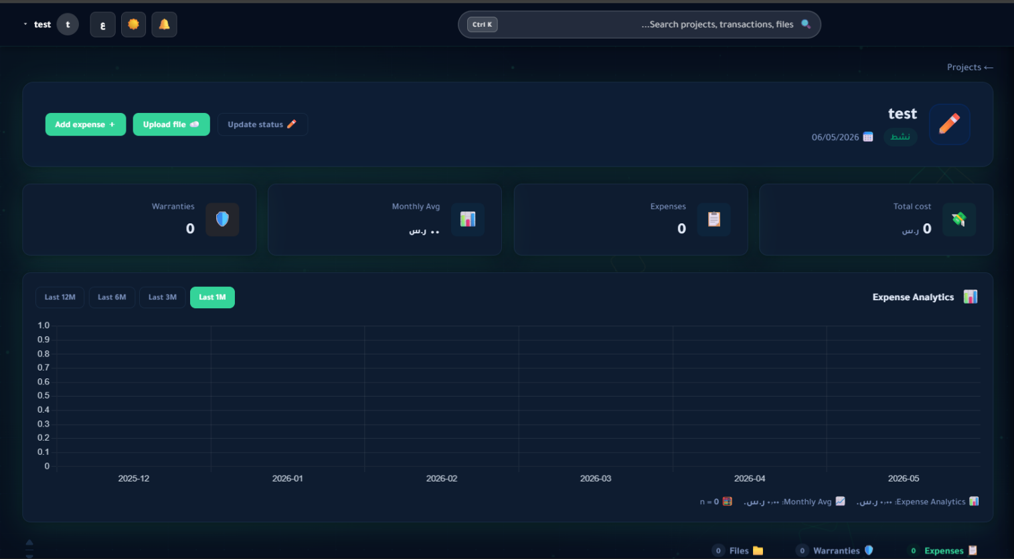
Figure 7Project Detail (pages/project-detail.php)
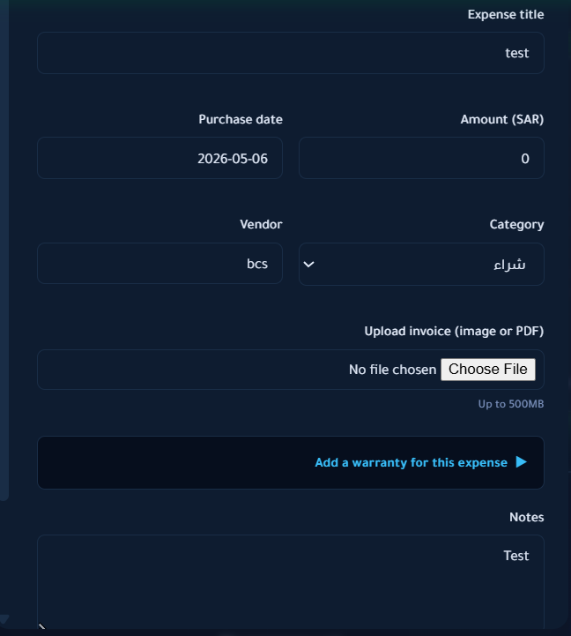
Figure 8 New Expanse
Amount Input Field (Object): Input (Action) -> Enforces DECIMAL(12,2) formatting client-side, restricting non-numeric characters.
Category Dropdown (Object): Select (Action) -> Updates internal state for budget categorization.

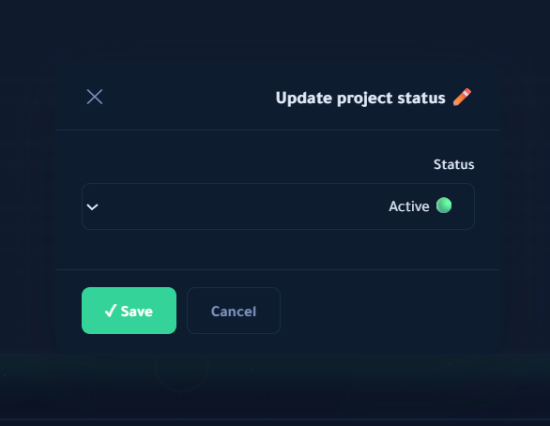
Figure 9 Update project status
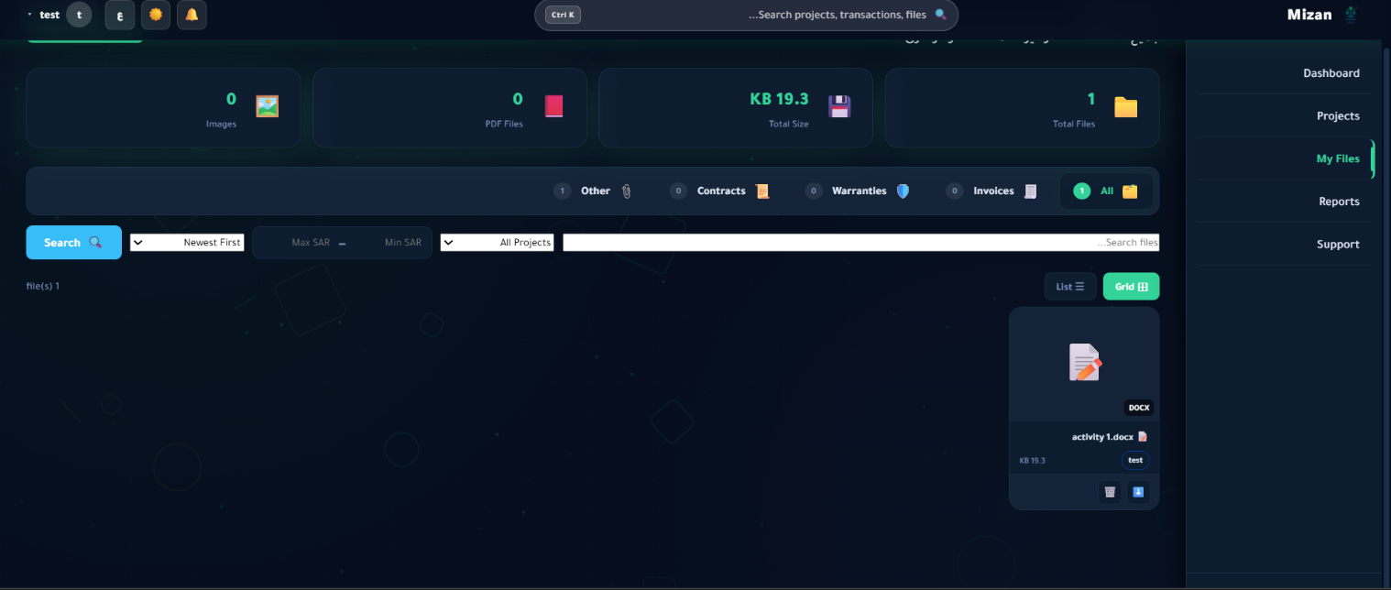
Figure 10Vault Screen (pages/files.php)
Drag-and-Drop Zone (Object): Drop Event (Action) -> Reads file magic-bytes and initiates a chunked or direct background upload to the File System Interface.
File Item Row (Object):
- Download Icon Click: Triggers OS-level file download prompt.
- Delete Icon Click: Triggers a SweetAlert2 confirmation dialogue before issuing a DELETE API request.

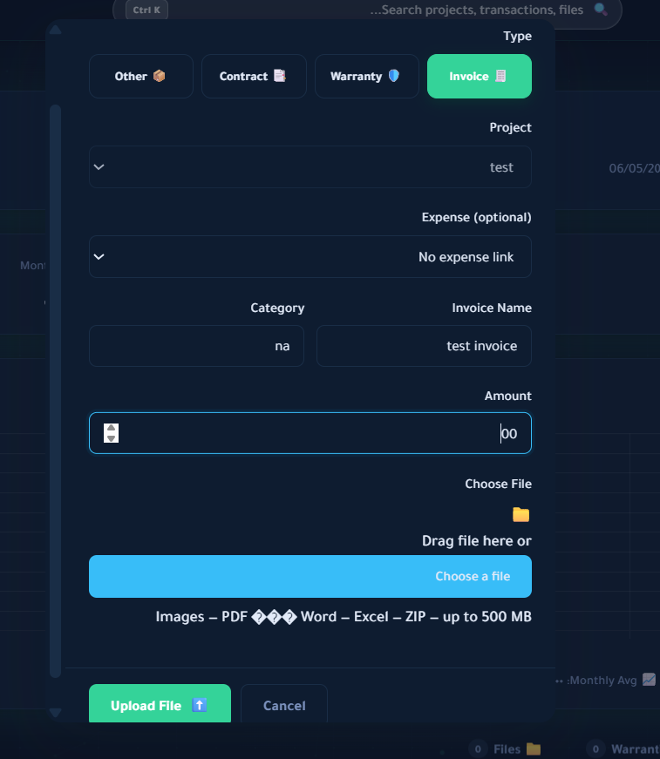
Figure 11 Upload files
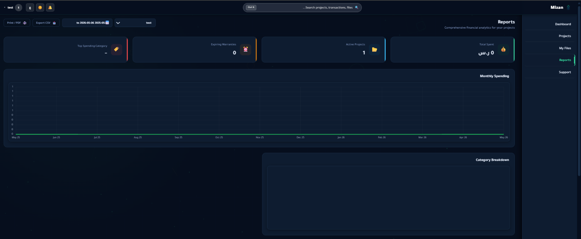
Figure 12 Reports Screen (pages/reports.php)
Chart.js Canvas (Object): Hover (Action) -> Triggers native Chart.js tooltip rendering data points.
Export "CSV / PDF" Buttons (Object): Click (Action) -> Client-side execution utilizing libraries (e.g., jsPDF) or an API call to generate and download the respective file format.

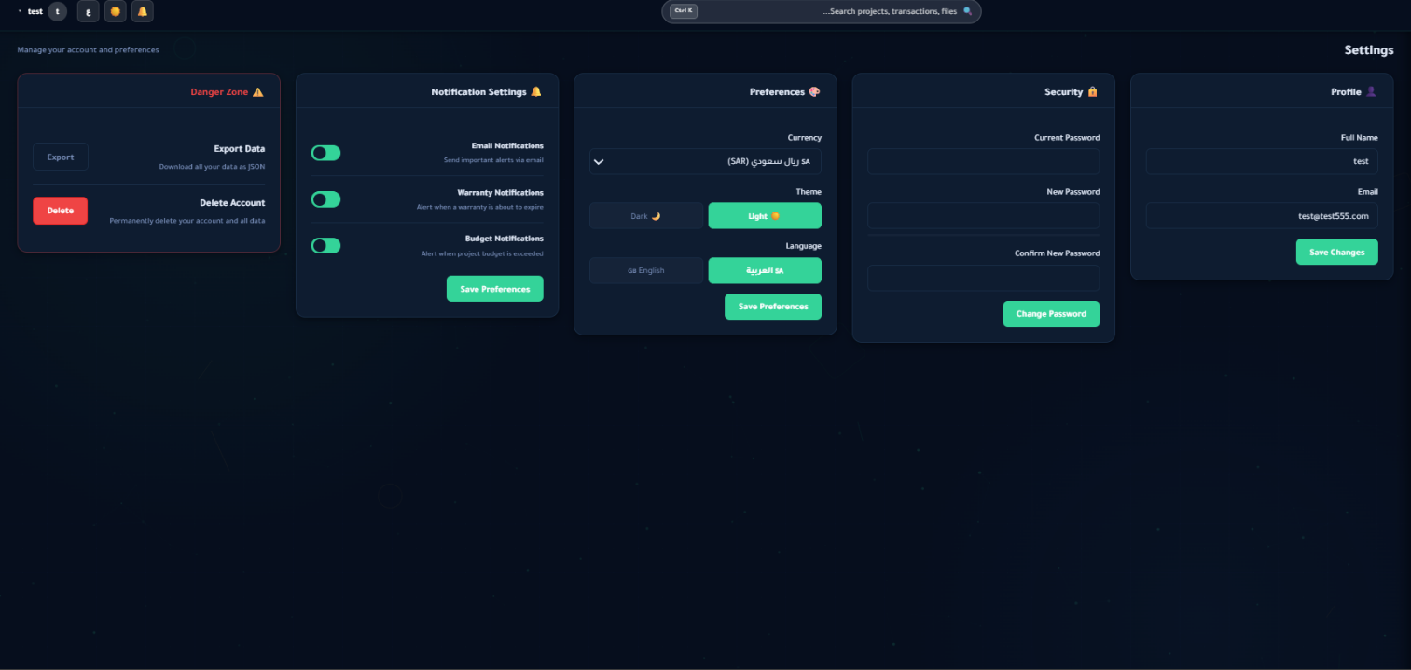
Figure 13Settings Screen (pages/settings.php)
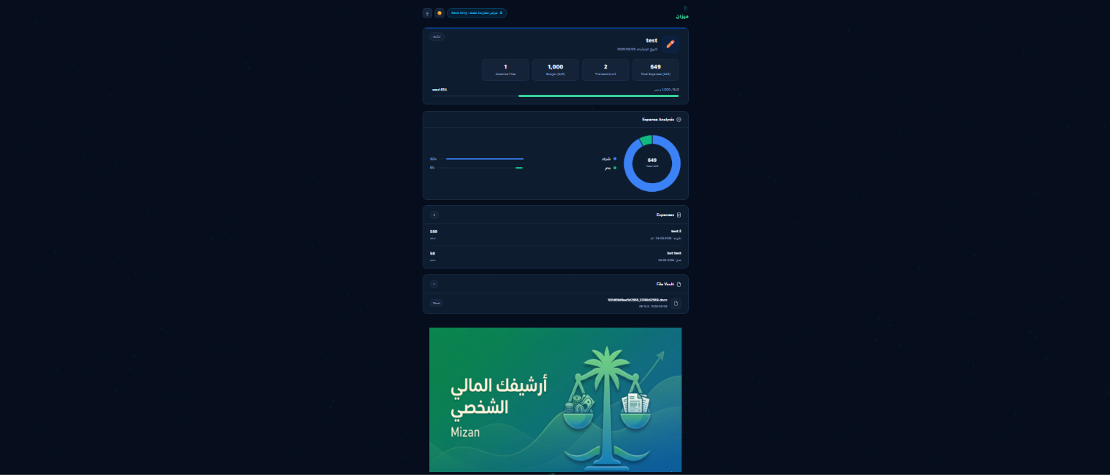
Figure 14Public Share Screen (share.php)

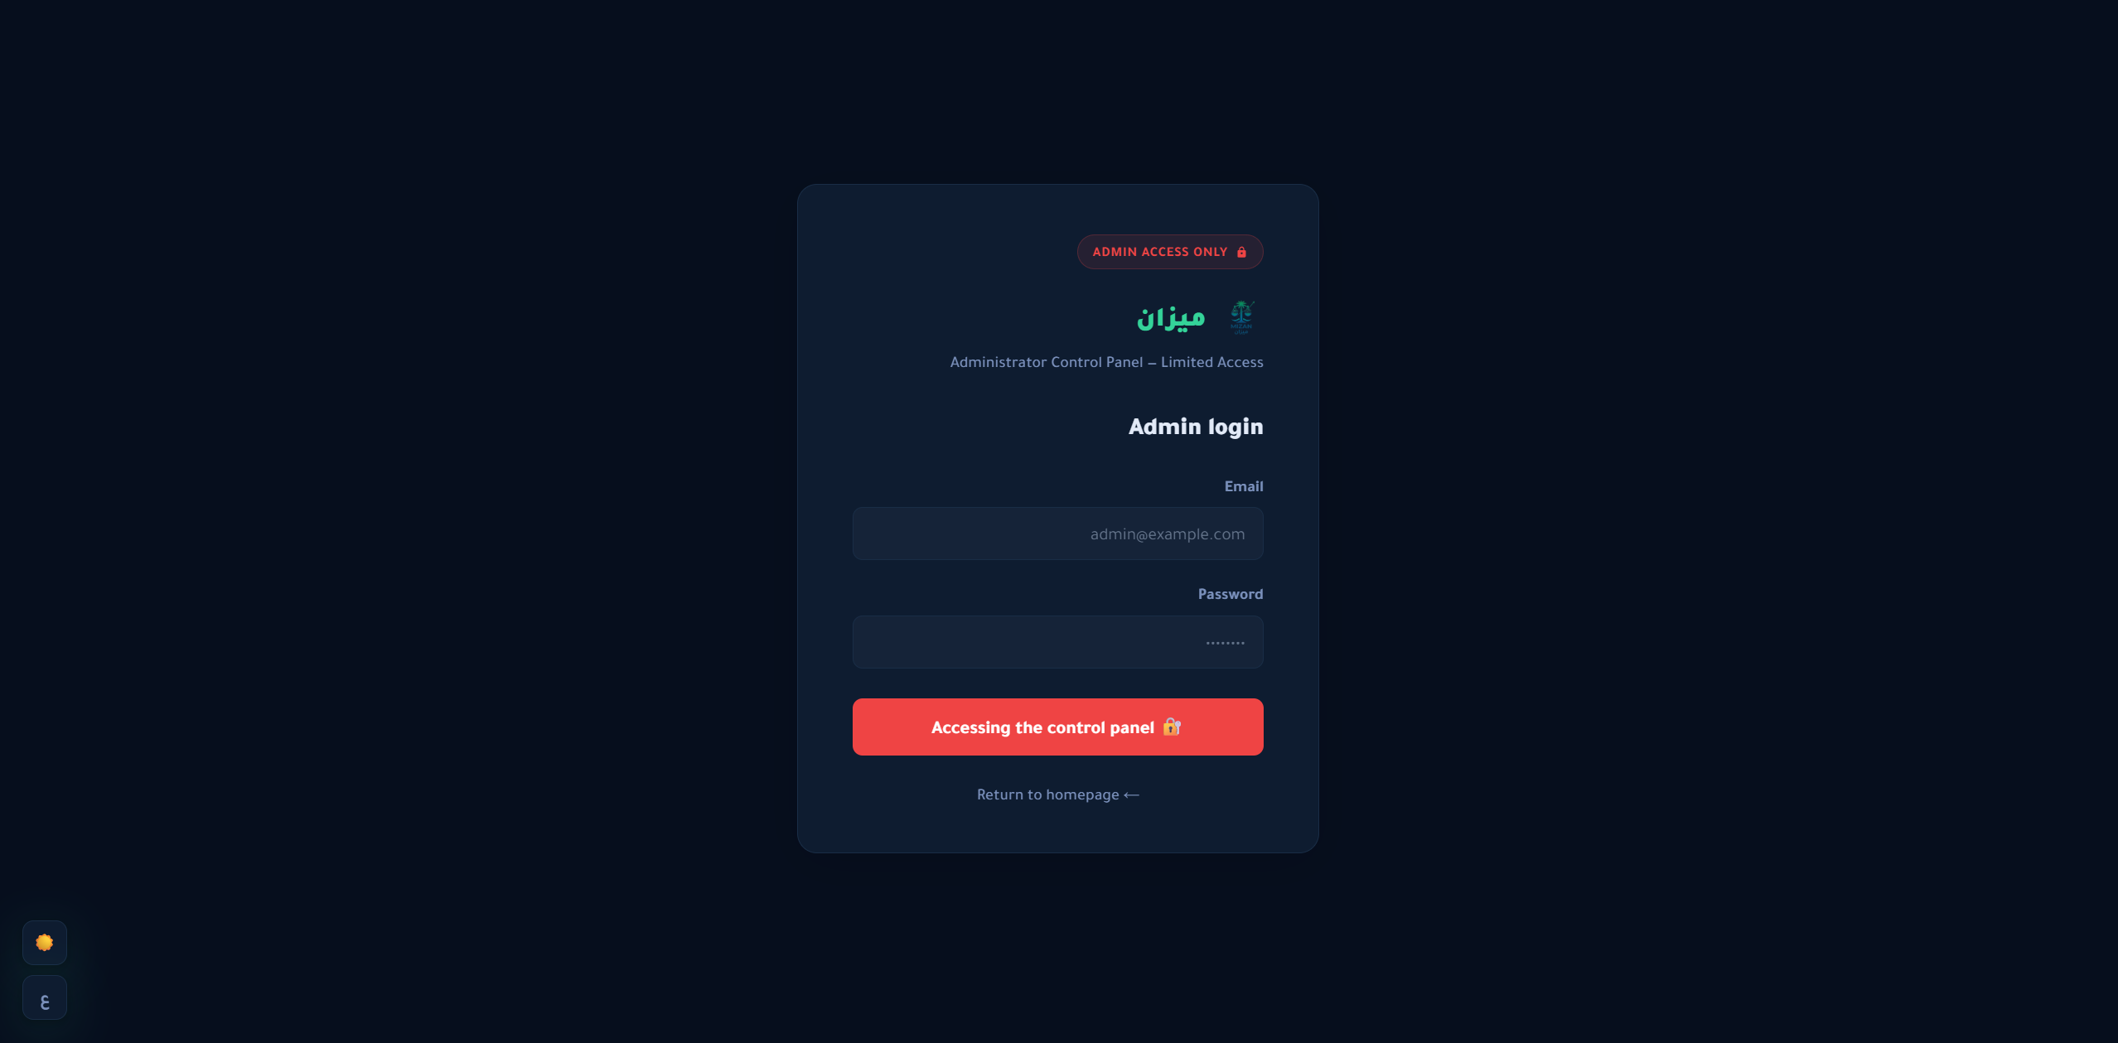
Figure 15admin_login.php

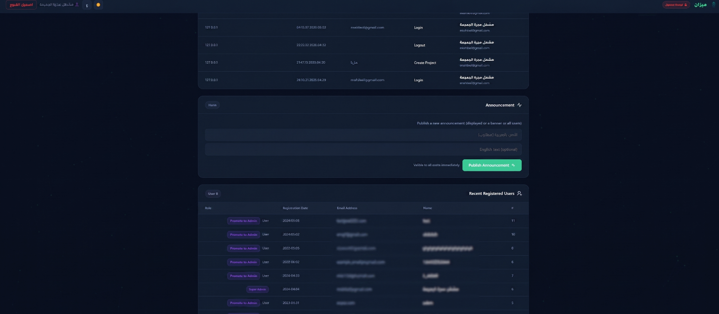
Figure 16admin/dashboard.php
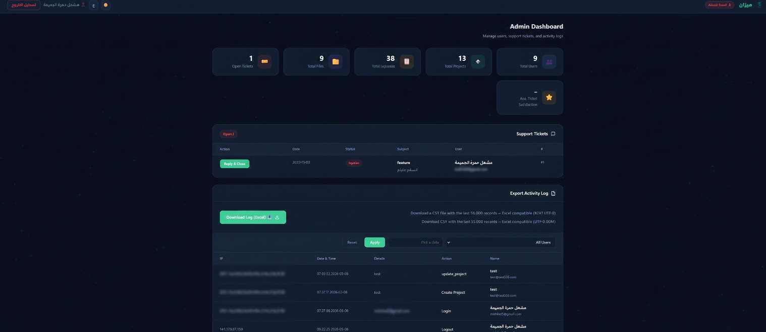
Figure 17admin/dashboard.php.2
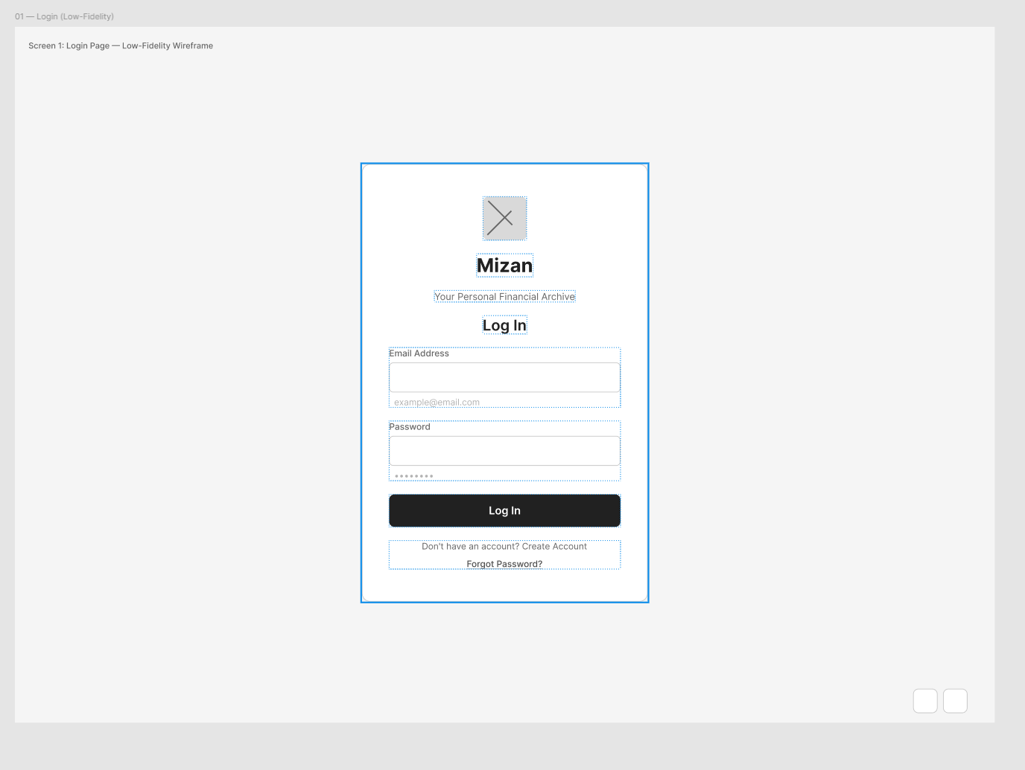
Figure 18 login_page.php — Low-Fidelity Wireframe
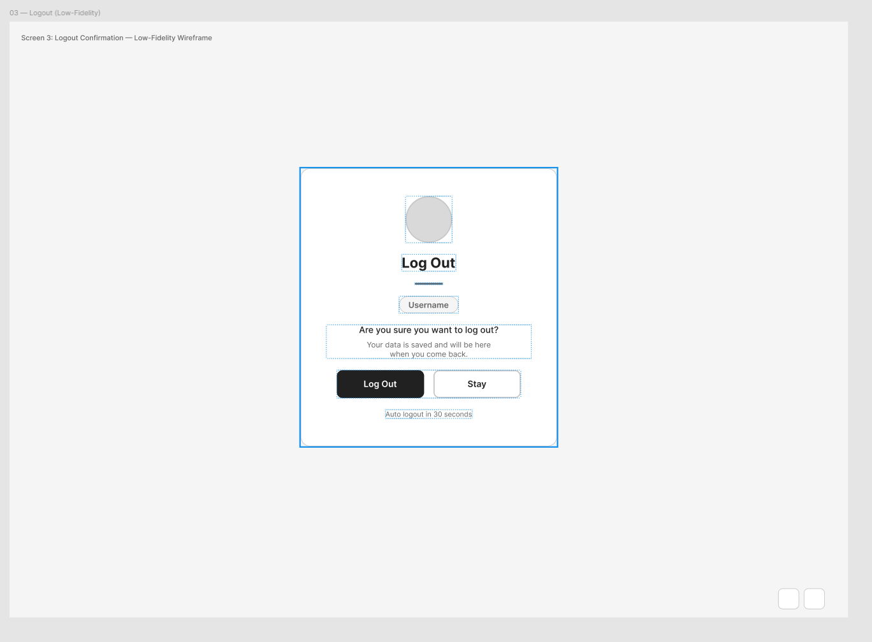
Figure 19 logout_confirmation.php — Low-Fidelity Wireframe

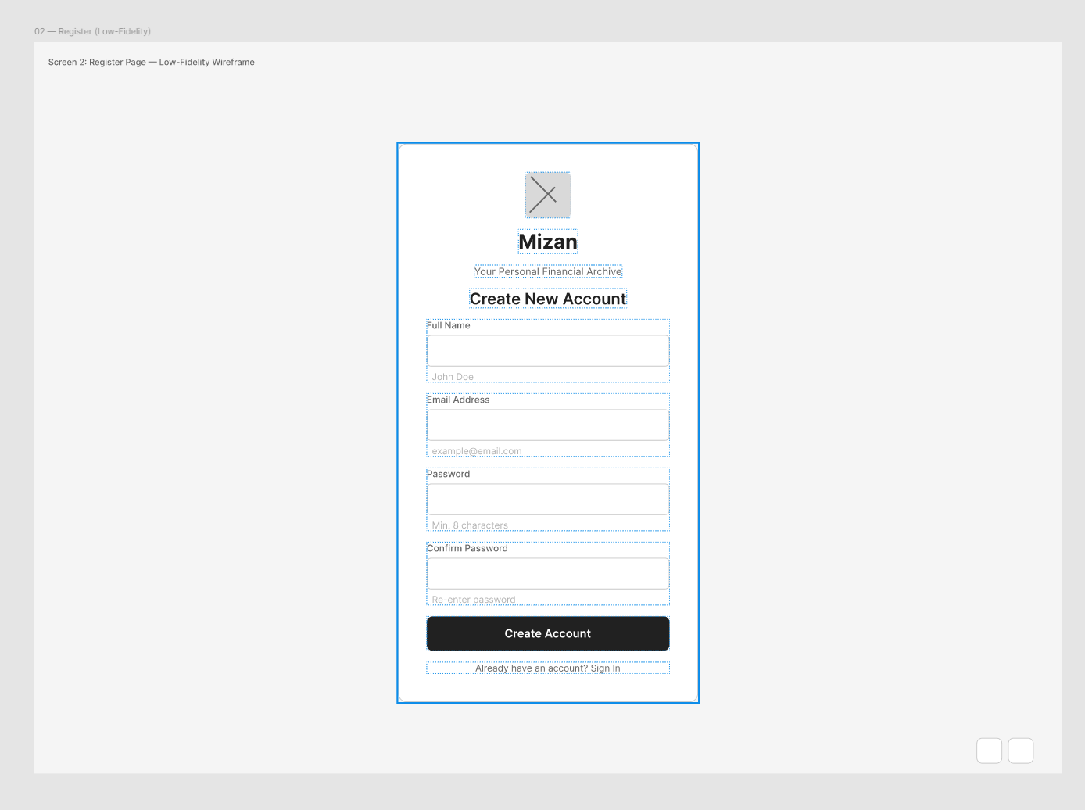
Figure 20account/signup.php — Low-Fidelity Wireframe

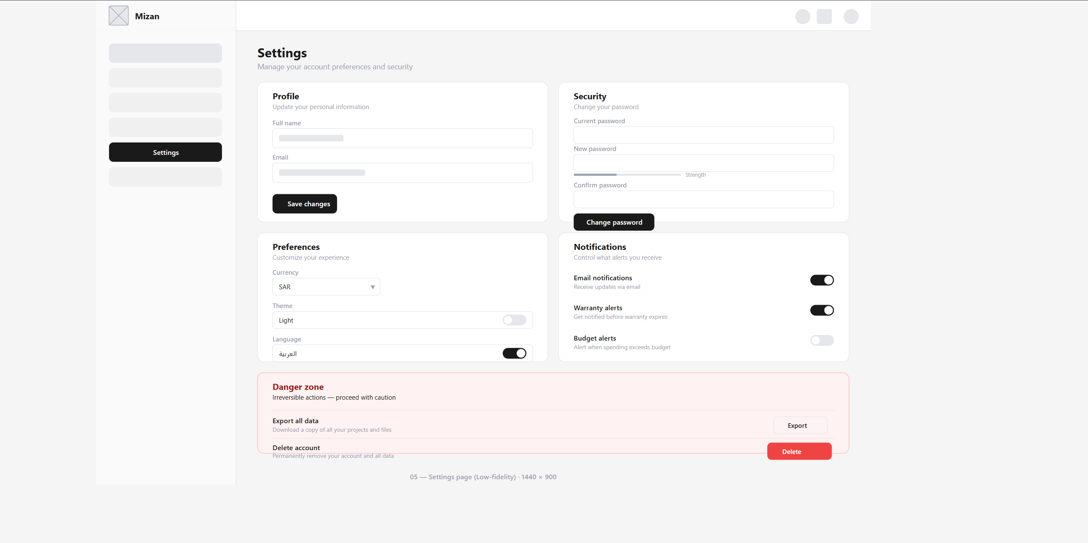
Figure 21settings/profile.php — Low-Fidelity Wireframe

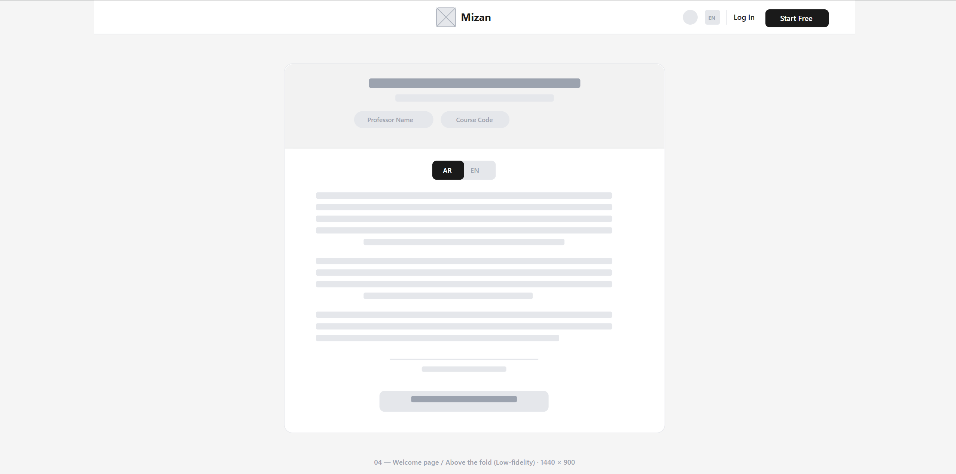
Figure 22 home.php — Low-Fidelity Wireframe

Other Interfaces

4.4.1 Email (SMTP) Interface
This interface deals with the interactions between the Mizan software and the outside SMTP server used to send automated emails (e.g., password resets and warranty expiration notifications).
- Technology: PHPMailer / SMTP.
- Protocol: SMTP via TLS/SSL (TCP Ports 587 or 465).
- Payload: MIME-encoded HTML emails in both Arabic and English.
- Connection Initialization/Closure: The interface initiates a connection with the SMTP server, performs an authentication based on credentials set within environmental variables, sends the email data, and closes the TCP connection right away.
- Error Handling: Issues such as timeout, authentication failure, or malformed recipient emails. Any exceptions here will be caught, logged to the activity_logs table, and will not terminate the user's session.

4.4.2 Internal REST-like API Interface
This interface establishes the method in which the client-side (Front-end JavaScript) communicates with the server-side (PHP Back-end) using asynchronous communication techniques.
- Technology: ES6+ JavaScript (mizanFetch) + PHP 8.
- Protocol: HTTP/HTTPS.
- Message Format: All messages sent and received are done through HTTP POST methods that can either contain URL-encoded messages or FormData messages.The response to the message received should be in the form of an envelope in standard JSON format { "success": Boolean, "data": Object, "message": String, "error": String }
- State Machine: Standard stateless HTTP request/response.
- Error States: * HTTP 403 - Forbidden (Incorrect CSRF token).
- HTTP 429 - Too Many Requests (Rate limit exceeded).
- HTTP 500 - Internal Server Error (Database connection issue).

4.4.3 File System Interface (Vault Module)
This API defines the manner in which the application will communicate with the underlying operating system storage system in order to handle user-uploaded invoices and warranties.
- Technology: PHP file I/O (move_uploaded_file, finfo).
- Protocol: Local Operating System file I/O system.
- Message Format: Binary data streams (formats supported in formats mapped in EXT_TO_MIME such as PDF, PNG, JPG).
- Initiation and Closure: The file is transferred into an operating system temporary directory, verified, and then transferred into the sandboxed upload/ {type}/{project_id} and file handler closed.
- Error Conditions: *
- File size exceeds the 500 MB limit.
  - MIME type magic-byte mismatch (Security violation).
  - Disk quota exceeded or directory permission denied (Returns a graceful JSON error to the user).

5. System Architecture
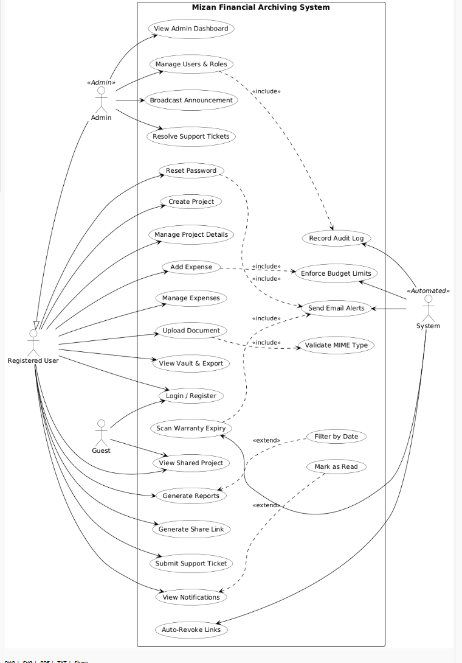
Figure 23Use Case Diagram

5.1 Architectural Design Approach
The selection of the decoupled 3-Tier architecture along with the REST APIs was preferred overusing a conventional "Monolithic" PHP web application (which combines HTML & PHP SQL in the same file). This is because the monolithic architecture would have been a non-starter due to violation of SoC principle, UI update problems, and heightened security concerns.
- By adopting our current API-oriented architecture, we get two key advantages: Rock-solid security separation (particularly for the admin system),
- Future-readiness, as the future mobile app (iOS/Android) would be able to consume the same backend APIs without making any changes to the backend itself.
the architectural basis of the Mizan system is entirely built on top of the principle of Separation of Concerns (SoC), employing a mixed approach of the good-old Three-Tier Architecture combined with the Model-View-Controller (MVC) paradigm. In short, all components of the application are separated in distinct tiers, meaning that cross-tier access is strictly forbidden from an architectural perspective.
- Presentation Tier (View Layer): This tier includes front-end routing scripts located in pages/ whose sole purpose is to render the UI and manage DOM state which sole purpose is to render the HTML page. These components do not operate with the database at all; instead, they retrieve and submit information to the back end via asynchronous fetch () calls.
- Application / Business Logic Tier (Controller Layer): This tier resides in the api/ directory, acting as a central component processing requests. Here we see the implementation of a REST-like service architecture, where each endpoint represents some domain model (e.g., User or Session). This tier requires implementing middleware, namely authentication, CSRF verification, authorizations, and request input sanitization. Endpoints return only JSON payloads which means separation between data passing and UI rendering.
- Data Tier (Model / Data Access Layer): This tier is managed via config/db.php and the MySQL database named mizan_db. In simple terms, this tier represents a Data Access Layer (DAL) which uses a PDO connection factory with an explicit enforcement of ATTR_EMULATE_PREPARES=false attribute ensuring server-side prepared statements on a hardware level which makes this tier safe against SQL injection attacks.
Architectural Motivation: Such an approach brings us the following advantages:
- Independent Upgrades: The Presentation and Application tiers are independent which allows for upgrading both tiers separately.
- Cross-Platform Readiness: The REST-like communication protocol will allow serving our application as an API in case of a need to develop a native mobile app for iOS/Android with no changes in the main back-end code.
- Separation of Security Domains: The Administrative subsystem operates under its own login gate and the dedicated session namespace which makes it impossible for users to escalate permissions via standard user sessions.

5.2 Architectural Design
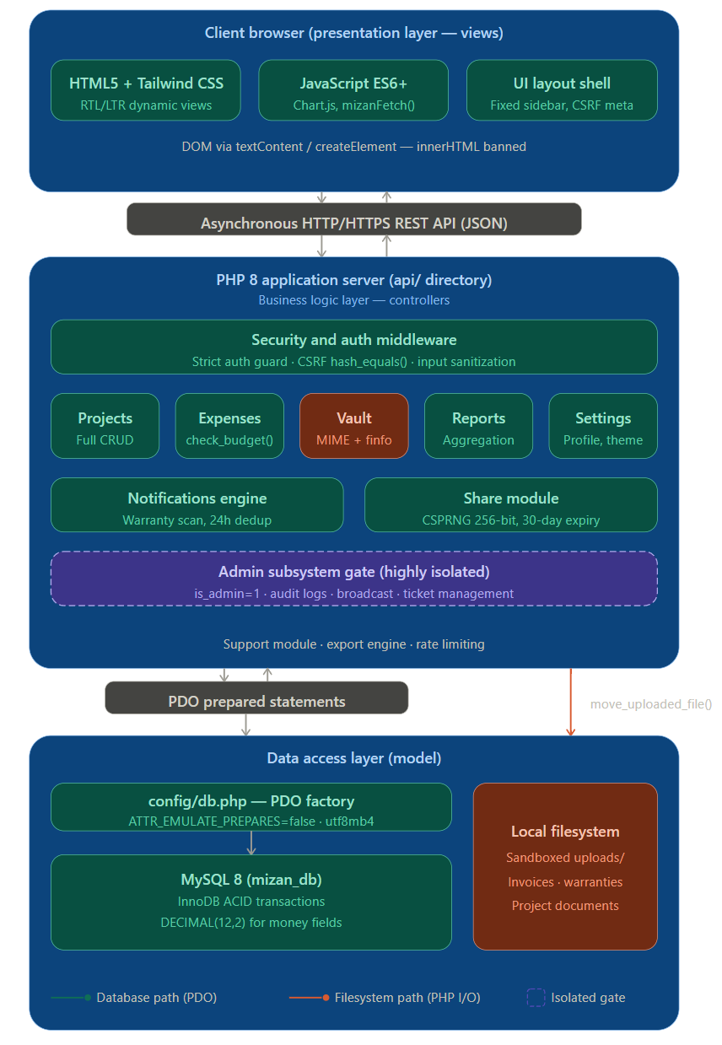
Figure 24Overall 3-Tier MVC System Architecture of Mizan

Overall, the architecture of the Mizan ensures that every authorized client-server communication process occurs securely and in a controlled manner. Below is the structured flow of the common request/response processing:
- Client (Browser) Request Initialization: The request is sent by the Client (Browser) to the Apache Web Server by using HTTP/HTTPS.
- Routing: Once the Apache Web Server has received the request, it will route the request to the specific PHP resource (Web Page / API endpoint).
- Middleware Authentication: The processing through middleware and authorization starts. The most important piece here is the includes/auth.php file, which provides multi-step authentication
- For Web Pages: Session tokens and CSRF tokens are checked.
- For API Endpoints: In case if the authorization parameters are either missing or invalid, the API endpoint will respond with a 401 response in JSON format.
- Logical Processing: Once all necessary processing of the incoming request has been done, Business Logic interacts with Data Tier in order to retrieve necessary information from there. It is done through the execution of secure PDO Prepared Statements of the MySQL database, or interaction with the Local Filesystem to store documents securely (e.g., Vault uploads).
- Return Payload: Different target resources will result in a different output, therefore, the API endpoints return JSON data envelops, whereas, page controllers generate HTML templates enhanced with JavaScript code.
- Rendering: The last step is rendering the User Interface inside the Browser. This step is also followed by making another set of asynchronous requests through mizanFetch() custom function.

Subsystem Architecture
The Mizan system consists of various self-contained subsystems that cater to business segments.

Document Vault Subsystem
Description: This subsystem is tasked with providing the necessary functionality for secure upload and archiving of tangible financial assets (such as invoices and agreements). A thorough, multi-layered process of security validation is used before any access to the local file system is established. The API ensures strict validation of CSRF tokens, imposes a maximum upload size of 500 MB, and rejects any attempt at upload manipulation by performing MIME type validation using magic-bytes technique on an approved list of extensions. Transactions with database insertions are performed under an explicit transaction block.
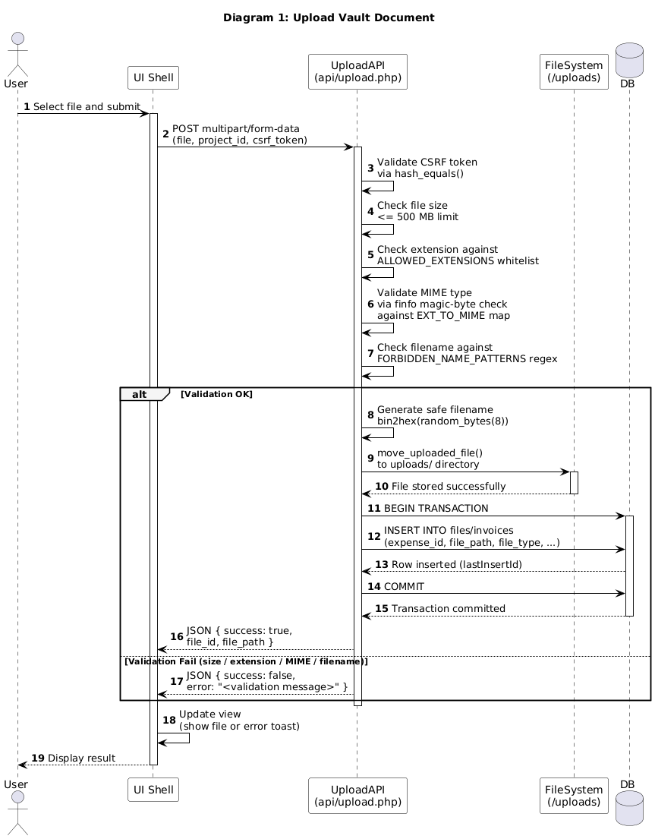
Figure 25Sequence Diagram 1 Upload Vault Document

Project Sharing & Access Control Subsystem
Description: This subsystem is responsible for distributing financial projects to external parties under controlled and read-only conditions. This process involves the use of Cryptographically Secure Pseudo-Random Number Generator (CSPRNG) by generating random tokens through PHP’s random_bytes(). This subsystem validates project ownership before issuing the tokens and attaches an expiry date (30 days) on the token for restricted access to shared resources.
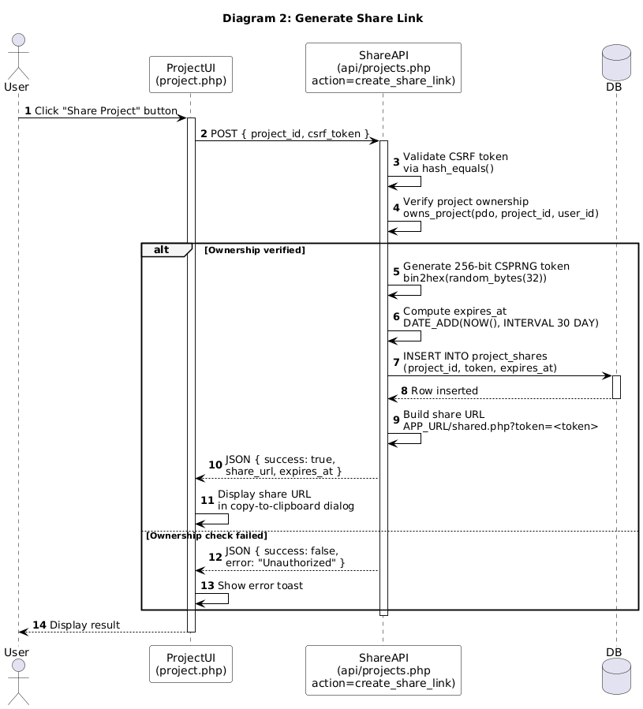
Figure 26 Sequence Diagram 2 Generate Share Link

Administrative Support & Ticketing Subsystem
Description: This subsystem operates under an isolated administrative security domain. It is responsible for handling user support ticket resolutions. It guarantees vertical privilege segregation by checking the value of is_admin session flag before performing any changes to the system. In order to keep a complete audit log, the subsystem combines the ticket status change, the reply creation, and the activity log recording into a single backend operation.
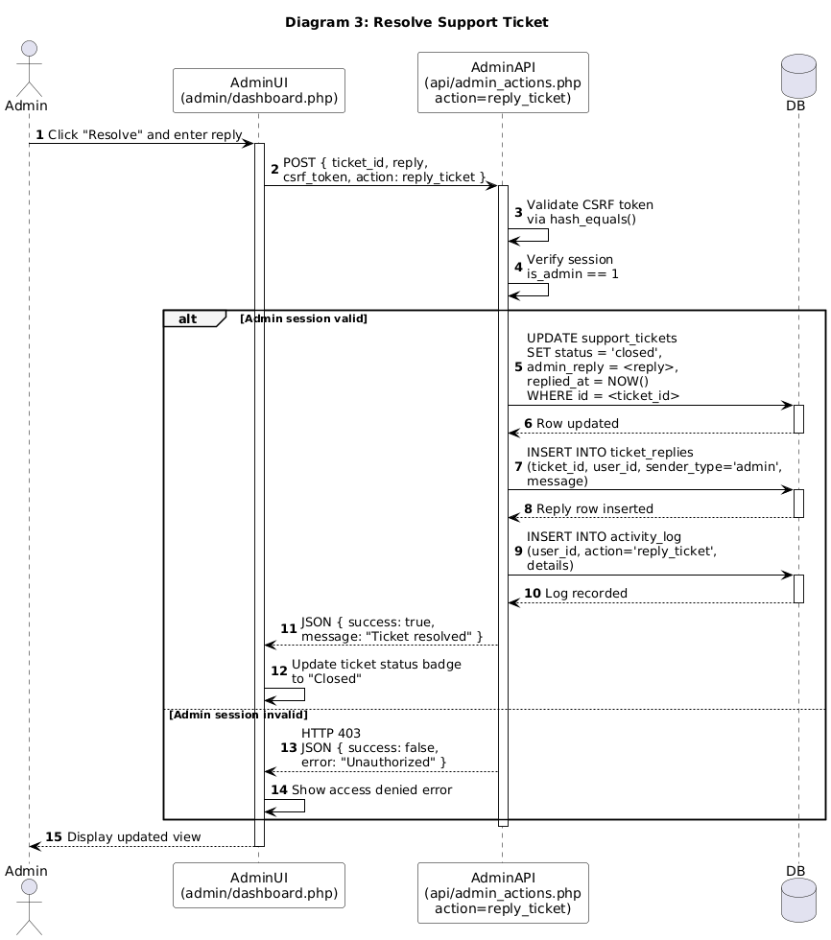
Figure 27 Sequence Diagram 3 Resolve Support Ticket

5.3.4 Global Broadcast & Announcement Subsystem
Description: The alert system allows administrators to send out system-wide messages and alerts. It shares similar characteristics with the ticketing system, including strict adherence to authorization from the administrator. In addition, the API employs extensive sanitization and truncation of input (e.g., restricting subject lines to 200 characters) to avoid database truncation and layout issues within the interface. Every successful message sent is automatically recorded within the system’s activity logger.
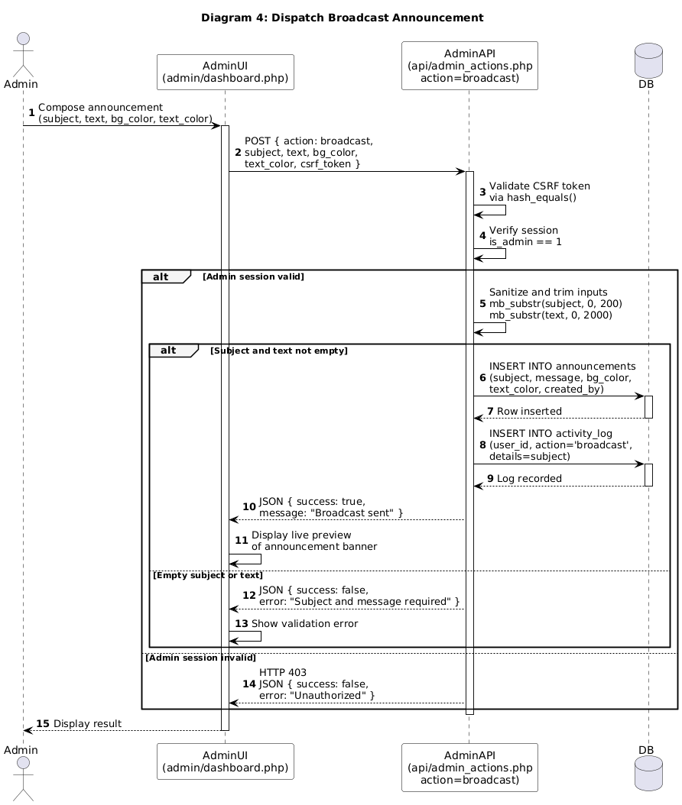
Figure 28 Sequence 4 Dispatch Broadcast Announcement

5.3.5 Automated State Revocation Subsystem (Link Expiry)
Description: The subsystem will help maintain the temporal security of the resources being shared. This is done without the need for any active user interaction using a job scheduler (Cron), which triggers the system at periodic intervals based on time to search the database for any expired tokens. With the help of an automated batch UPDATE operation, the subsystem retracts permissions of all users whose expiry date has already passed.
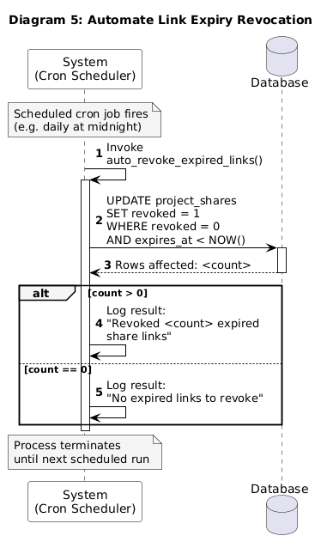
Figure 29 Sequence Diagram 5 Automate Link Expiry Revocation

5.3.6 Expense Processing & Budgeting Subsystem
Description: This subsystem is responsible for the management of the lifecycle of financial transactions. Its security is maintained by the rigorous process of data sanitization, CSRF checks, and transaction commits within the database. Besides, this subsystem comes equipped with a budget threshold calculator, which triggers automatic alerts for overspending.

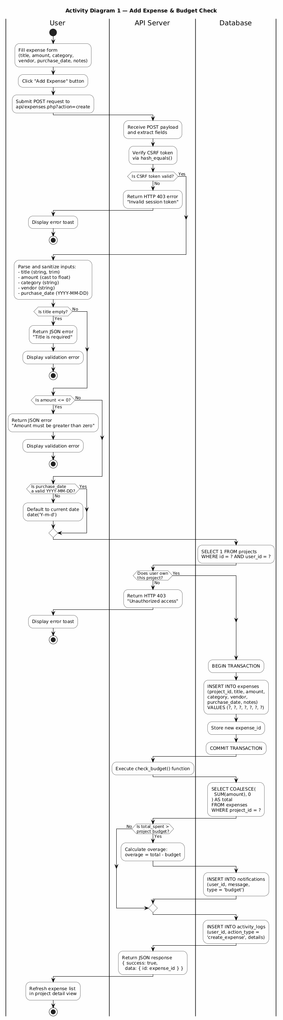
Figure 30Activity 1: Add Expense & Budget Validation

5.3.7 Guest Authorization & Read-Only Presentation Subsystem
Description: The subsystem manages access to shared financial projects from an external, trustless perspective. It checks incoming guest tokens for validity, sanitizes the payload, and verifies that the token is not expired. Once authenticated, the system builds a full data model and hides all UI elements that would allow the guest to modify the system’s state.

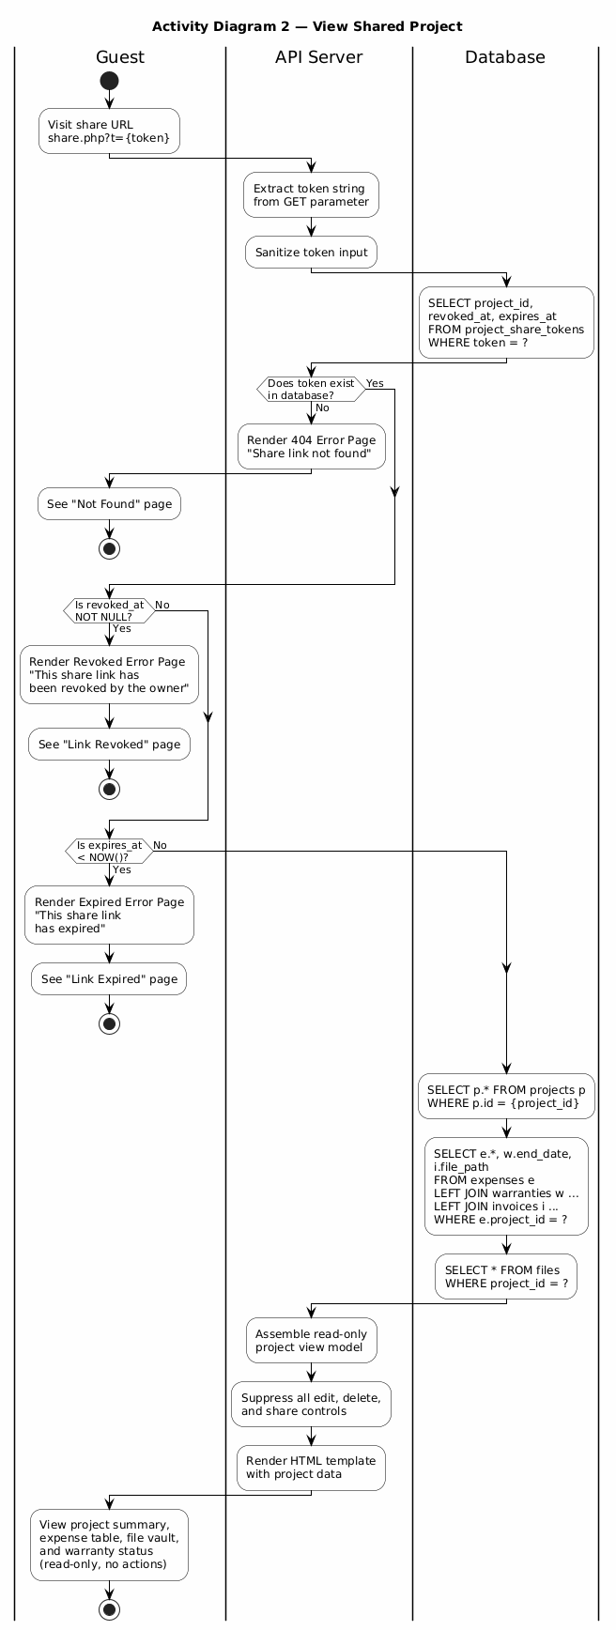
Figure 31 Activity 2: View Shared Project

5.3.8 On-Demand Warranty Notification Subsystem
Description: This component cleverly circumvents the environmental limitation of the absence of background cron services by running only during the UI interaction process. This system initiates the execution process when the end user seeks to retrieve notifications by checking the database for expired warranties. It has an efficient 24-hour deduplication system to avoid database flooding.
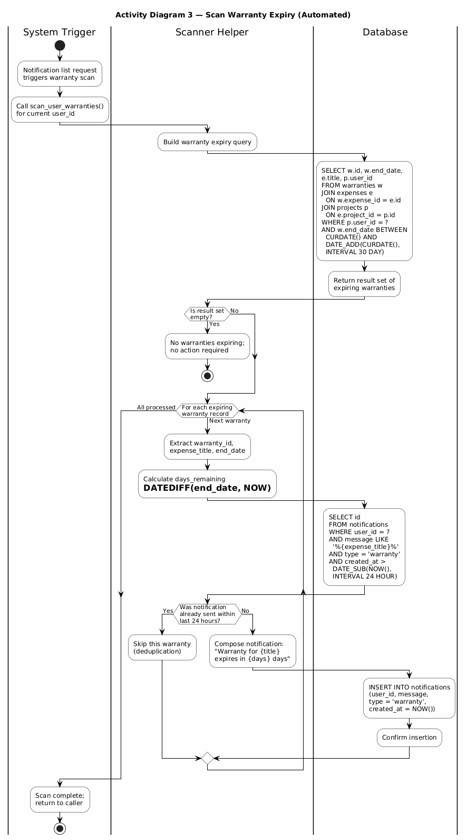
Figure 32Activity 3: Scan Warranty Expiry (Automated)

5.3.9 Administrative Lifecycle & Data Eradication Subsystem
Description: As a subsystem in charge of managing the total and irrevocable account deletion, this subsystem verifies the privileges of administrators to safeguard against any form of vertical privilege escalation and ensures that any super admin accounts cannot be deleted. It implements an extremely thorough cleanup process where database cascades go together with the actual deletion of artifacts on the local filesystem.
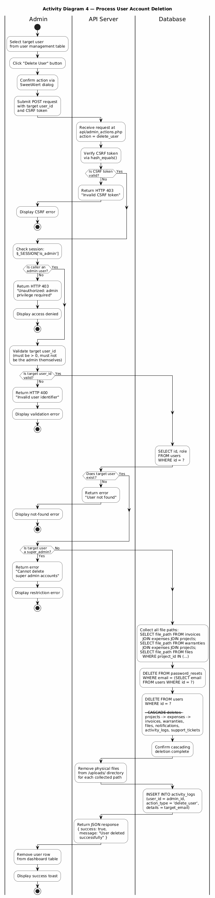
Figure 33Activity 4: Process User Account Deletion

5.3.10 User Feedback & Engagement Subsystem
Description: The logical process controls the harvesting of quality data related to the platform. It checks numerical ratings within the required limits and performs rigorous sanitization of the string inputs from the user. In order to encourage the users, the logical process supports state-based conditional branching and uses the SMTP interface for sending out confirmation emails asynchronously.
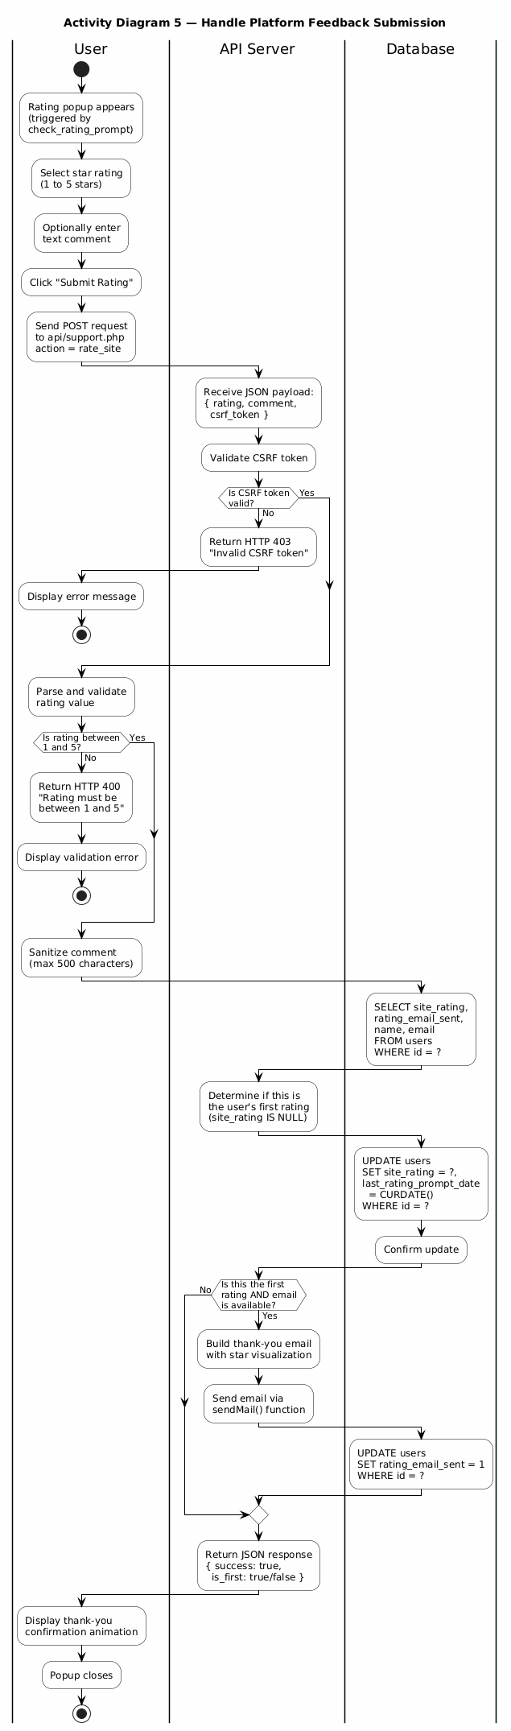
Figure 34Activity 5: Handle Platform Feedback Submission

5.3.11 Deep File Verification & Security Subsystem
Description: Operating as the first line of defense from malicious file attacks, this pipeline inspects the uploaded file in various phases for its validation. This involves checking the PHP error codes, setting limits on the hardware side, verifying filenames through regular expressions, and most importantly, validating user-provided file extensions with hardware-based MIME type check using finfo_file() function.
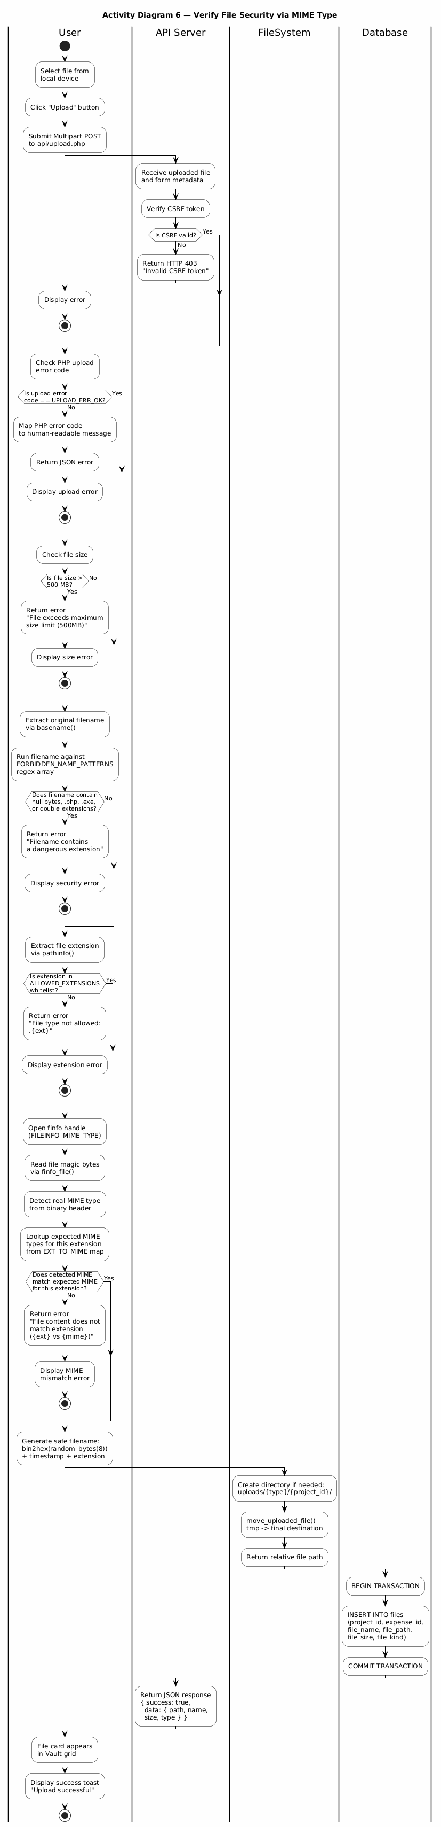
Figure 35Activity 6: Verify File Security via MIME Type

6. Data Design

6.1 Data Description
- All persistent data is stored in MySQL 8 database mizan_db using utf8mb4 (full Unicode including Arabic). All tables use InnoDB for ACID compliance and foreign key support.
- Financial Precision: every monetary column (expenses.amount, projects.budget, projects.sell_price) uses DECIMAL(12,2). This is a hard engineering constraint - FLOAT and DOUBLE are IEEE 754 binary types that cannot represent most decimal fractions exactly, causing rounding artefacts such as 99.99 becoming 99.98999... after arithmetic. DECIMAL stores exact fixed-point values, ensuring all financial totals, profit/loss calculations, and budget comparisons are accurate to the cent.
- All foreign keys use ON DELETE CASCADE. Deleting a user removes all their projects; deleting a project removes all its expenses, files, warranties, and invoices - ensuring no orphaned records
- The activity_logs table is append-only and exempt from CASCADE deletion, preserving the audit trail even after account deletion.

6.2 Data Dictionary
- All other tables follow the same pattern. projects links to users (user_id FK CASCADE)
- expenses links to projects (project_id FK CASCADE).
- warranties and invoices link to expenses (expense_id FK CASCADE). files links to projects and optional expenses.
- notifications, support_tickets, and ratings link to users.
- project_share links to projects.
- password_resets, login_attempts, and announcements are standalone tables.
- Etc…
Column | Type | Attributes | Null | Default
id | INT | AUTO_INCREMENT, PRIMARY KEY | NO
name | VARCHAR(100) |  | NO
email | VARCHAR(150) | UNIQUE | NO
password | VARCHAR(255) |  | NO
currency | VARCHAR(10) |  | NO | 'SAR'
created_at | TIMESTAMP |  | NO | CURRENT_TIMESTAMP
theme | VARCHAR(10) |  | NO | 'light'
language | VARCHAR(5) |  | NO | 'ar'
notif_email | TINYINT(1) |  | NO | 1
notif_warranty | TINYINT(1) |  | NO | 1
minibudget | TINYINT(1) |  | NO | 1
is_admin | TINYINT(1) |  | NO | 0
site_rating | TINYINT |  | YES
rating_email_sent | TINYINT(1) |  | NO | 0
last_rating_prompt_date | DATE |  | NO
role | varchar(20) |  | NO | User
Table 2 Users

Column | Type | Attributes | Null | Default
id | INT | AUTO_INCREMENT, PRIMARY KEY | NO
user_id | INT | FOREIGN KEY (user_id) REFERENCES users(id) ON DELETE CASCADE | NO
name | VARCHAR(200) |  | NO
type | ENUM('car','house','occasion','work','devices','custom') |  | YES | 'custom'
status | ENUM('active','done','archived') |  | YES | 'active'
budget | DECIMAL(12,2) |  | YES | 0.00
sell_price | DECIMAL(12,2) |  | YES | 0.00
color | VARCHAR(10) |  | YES | '#3b82f6'
notes | TEXT |  | YES
created_at | TIMESTAMP |  | YES | CURRENT_TIMESTAMP
nature | ENUM('personal','commercial') |  | YES | 'personal'
Table 3 Projects

Column | Type | Attributes | Null | Default
id | INT | AUTO_INCREMENT, PRIMARY KEY | NO
project_id | INT | FOREIGN KEY (project_id) REFERENCES projects(id) ON DELETE CASCADE | NO
title | VARCHAR(200) |  | NO
amount | DECIMAL(12,2) |  | NO
category | VARCHAR(100) |  | YES
vendor | VARCHAR(150) |  | YES
purchase_date | DATE |  | YES
notes | TEXT |  | YES
created_at | TIMESTAMP |  | YES | CURRENT_TIMESTAMP
Table 4Expenses

Column | Type | Attributes | Null | Default
id | INT | AUTO_INCREMENT, PRIMARY KEY | NO
expense_id | INT | FOREIGN KEY (expense_id) REFERENCES expenses(id) ON DELETE CASCADE | NO
start_date | DATE |  | YES
end_date | DATE |  | YES
file_path | VARCHAR(255) |  | YES
notes | VARCHAR(255) |  | YES
Table 5 Warranties
Column | Type | Attributes | Null | Default
id | INT | AUTO_INCREMENT, PRIMARY KEY | NO
expense_id | INT | FOREIGN KEY (expense_id) REFERENCES expenses(id) ON DELETE CASCADE | NO
file_path | VARCHAR(255) |  | NO
file_type | VARCHAR(20) |  | YES | 'image'
uploaded_at | TIMESTAMP |  | YES | CURRENT_TIMESTAMP
Table 6 Invoices

Column | Type | Attributes | Null | Default
id | INT | AUTO_INCREMENT, PRIMARY KEY | NO
project_id | INT | FOREIGN KEY (project_id) REFERENCES projects(id) ON DELETE CASCADE | NO
expense_id | INT |  | YES
file_name | VARCHAR(255) |  | NO
file_path | VARCHAR(500) |  | NO
file_size | INT |  | YES | 0
uploaded_at | TIMESTAMP |  | YES | CURRENT_TIMESTAMP
file_kind | ENUM('invoice','warranty','contract','other') |  | YES | 'other'
Table 7 Files
Column | Type | Attributes | Null | Default
id | INT | AUTO_INCREMENT, PRIMARY KEY | NO
user_id | INT | FOREIGN KEY (user_id) REFERENCES users(id) ON DELETE CASCADE | NO
message | TEXT |  | NO
type | VARCHAR(50) |  | YES | 'general'
is_read | TINYINT(1) |  | YES | 0
created_at | TIMESTAMP |  | YES | CURRENT_TIMESTAMP
Table 8Notifications

Column | Type | Attributes | Null | Default
id | INT | AUTO_INCREMENT, PRIMARY KEY | NO
email | VARCHAR(150) |  | NO
token | VARCHAR(255) |  | NO
expires_at | TIMESTAMP |  | NO
Table 9 Password_resets

Column | Type | Attributes | Null | Default
id | INT | AUTO_INCREMENT, PRIMARY KEY | NO
ip_address | VARCHAR(45) |  | NO
attempts | INT |  | YES | 1
last_attempt | TIMESTAMP |  | YES | CURRENT_TIMESTAMP
Table 10Login_attempt

Column | Type | Attributes | Null | Default
id | INT | AUTO_INCREMENT, PRIMARY KEY | NO
project_id | INT | FOREIGN KEY (project_id) REFERENCES projects(id) ON DELETE CASCADE | NO
user_id | INT | FOREIGN KEY (user_id) REFERENCES users(id) ON DELETE CASCADE | NO
token | CHAR(64) | UNIQUE | NO
expires_at | DATETIME |  | NO
revoked_at | DATETIME |  | YES
created_at | TIMESTAMP |  | YES | CURRENT_TIMESTAMP
Table 11Project_share

Column | Type | Attributes | Null | Default
id | INT | AUTO_INCREMENT, PRIMARY KEY | NO
user_id | INT | FOREIGN KEY (user_id) REFERENCES users(id) ON DELETE CASCADE | NO
action_type | VARCHAR(50) |  | NO
details | TEXT |  | YES
ip_address | VARCHAR(45) |  | YES
created_at | TIMESTAMP |  | YES | CURRENT_TIMESTAMP
Table 12Activity_logs
Column | Type | Attributes | Null | Default
id | INT | AUTO_INCREMENT, PRIMARY KEY | NO
user_id | INT | FOREIGN KEY (user_id) REFERENCES users(id) ON DELETE CASCADE | NO
subject | VARCHAR(255) |  | NO
message | TEXT |  | NO
status | ENUM('open','closed') |  | YES | 'open'
created_at | TIMESTAMP |  | YES | CURRENT_TIMESTAMP
admin_reply | VARCHAR(2000) |  | YES
replied_at | DATETIME |  | YES
Table 13Support_tickets

Column | Type | Attributes | Null | Default
id | INT | AUTO_INCREMENT, PRIMARY KEY | NO
message_ar | VARCHAR(500) |  | NO
message_en | VARCHAR(500) |  | YES | ''
is_active | TINYINT(1) |  | YES | 1
created_at | TIMESTAMP |  | YES | CURRENT_TIMESTAMP
expires_at | DATETIME |  | YES
Table 14Announcements
Column | Type | Attributes | Null | Default
id | INT | AUTO_INCREMENT, PRIMARY KEY | NO
ticket_id | INT |  | NO
user_id | INT |  | NO | user
sender_type | enum('user', 'admin') |  | NO
message | text |  | NO
created_at | datetime |  | NO | current_timestamp()
Table 15 ticket_replies

6.3 Database Description
Complete overview of all 14 database tables, their key columns, and system roles:
Table | Key Columns | Description
users | id, name, email, password, is_admin, currency, theme, language, notif_email, notif_warranty, notif_budget | Stores registered user accounts with all preferences. Passwords stored as bcrypt hash. Includes is_admin flag to enforce RBAC for the admin dashboard.
projects | id, user_id, name, type, status, budget, sell_price, color, notes, nature | Central entity linked to a user. The nature column controls analytics mode. Budget enables over-budget notifications via check_budget().
expenses | id, project_id, title, amount, category, vendor, purchase_date, notes | Individual financial entries. Amount is DECIMAL(12,2). Aggregate SUM drives dashboard totals and budget checks.
warranties | id, expense_id, start_date, end_date, file_path, notes | Linked to an expense. Scanned daily-on-demand by scan_user_warranties() to push expiry notifications 30 days before end_date.
invoices | id, expense_id, file_path, file_type, uploaded_at | Receipt/invoice images or PDFs attached to an expense.
files | id, project_id, expense_id, file_name, file_path, file_size, file_kind, uploaded_at | General Vault files. file_kind ENUM drives the Vault filter tabs.
notifications | id, user_id, message, type, is_read, created_at | In-system alerts. Generated automatically for warranty expiry and budget overrun events.
password_resets | id, email, token, expires_at | Time-limited CSPRNG tokens for password reset. Expired tokens rejected.
login_attempts | id, ip_address, attempts, last_attempt | Rate-limiting table. Tracks failed login attempts per IP against brute-force attacks.
project_share | id, project_id, token, expires_at, revoked | Secure read-only share links. Token is 256-bit CSPRNG hex string.
activity_logs | id, user_id, action_type, details, ip_address, created_at | Append-only audit trail. Logs significant actions. Never deleted via CASCADE.
support_tickets | id, user_id, subject, message, status, created_at | Help-desk tickets. Status ENUM: open/in_review/resolved. Managed via admin dashboard.
announcements | id, message, bg_color, text_color, font_size, is_active, created_at | Stores global platform broadcast banners. Managed via the Admin Dashboard live-preview tool.
ticket_replies | id ,ticket_id , user_id ,sender_type, message, created_at | The actual text body of the reply ticket
Table 16 (14 database tables)
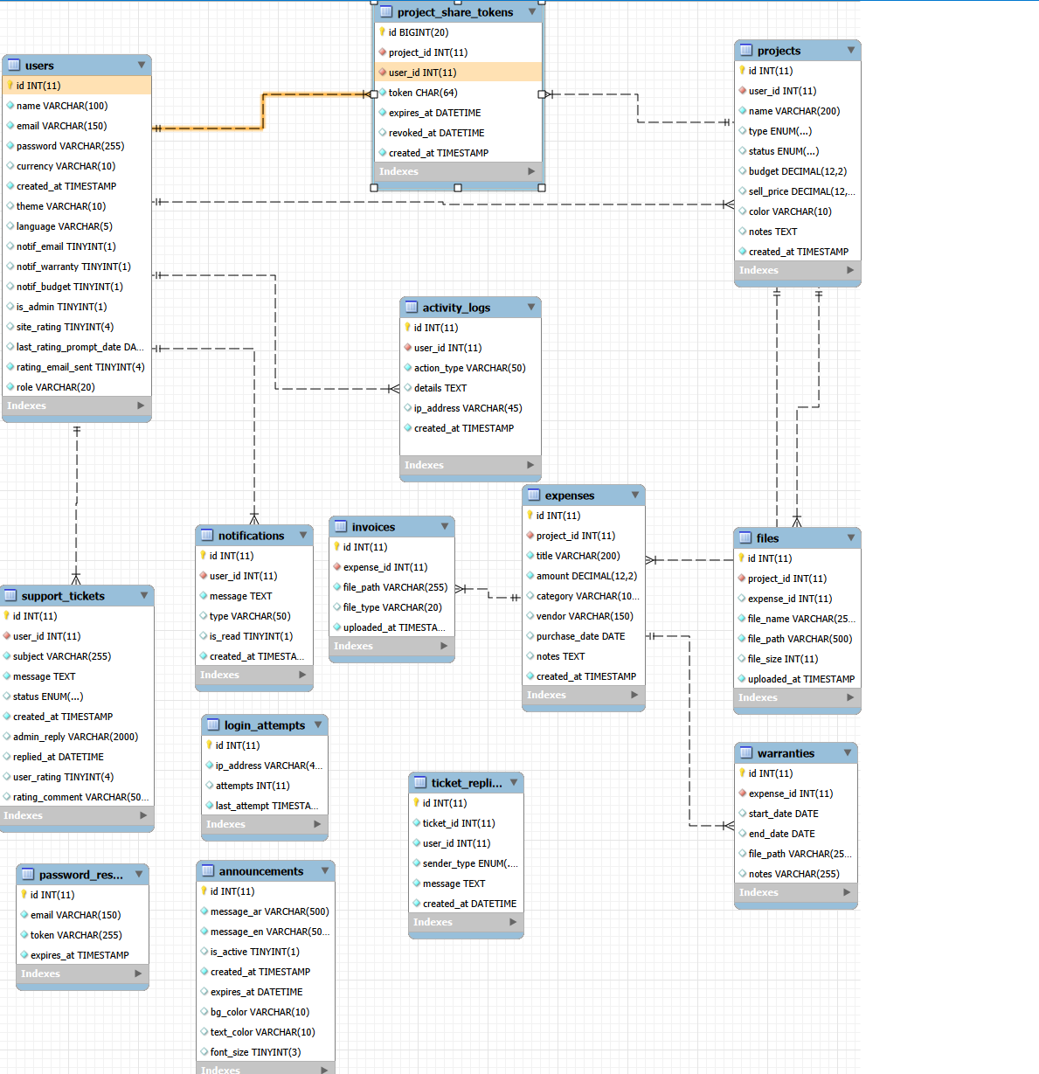
Figure 36 ERD Diagram

7. Component Design

7.1 Component Overview & Source Mapping
Component | Source Files | Responsibilities
Database Configuration [NEW] | includes/db.php | Initializes the PDO MySQL connection. Enforces utf8mb4 charset and strictly sets ATTR_EMULATE_PREPARES=false to prevent SQL injection across the entire application.
Authentication Module | login.php, register.php, logout.php, forgot-password.php, reset-password.php | Full user identity lifecycle: registration (bcrypt hash), session-based login, CSRF-protected logout, CSPRNG token-based password reset via SMTP. Rate-limited via login_attempts table.
Session & Auth Guard | includes/auth.php | Validates active session on every protected page. Generates CSRF token once per session via bin2hex(random_bytes(32)). Redirects unauthenticated users to login.
Core JavaScript Engine [NEW] | assets/js/main.js | Houses the custom mizanFetch() AJAX wrapper, handles the Double-Submit Guard logic, and manages frontend DOM updates securely.
Dashboard | index.php | Aggregates key metrics: total expenses, active project count, expiring warranty count. Renders a 6-month Chart.js line graph from the expenses table.
Projects Module | pages/projects.php, api/projects.php | Full CRUD for projects. Handles listing, creation, status updates, and deletion with CASCADE. Validates ownership on every write.
Expenses Module | api/expenses.php | Full CRUD for expenses. Amount stored as DECIMAL(12,2). Auto-triggers check_budget() on INSERT; pushes notification if total exceeds projects.budget.
Vault / Files Module | pages/files.php, api/upload.php | Unified upload (max 500 MB). Validates via EXT_TO_MIME map + PHP finfo magic-byte check. Stores to uploads/{type}/{project_id}/.
Warranty Tracker | pages/warranties.php, includes/notifications_helper.php | scan_user_warranties() queries warranties expiring within 30 days. Deduplication: NOT EXISTS check prevents re-notifying within 24 hours.
Reports Module | pages/reports.php, api/reports.php | Chart.js visualisations: monthly bar, category doughnut, commercial P&L line. CSV export streamed server-side; PDF via browser print.
Notifications Module | api/notifications.php, includes/notifications_helper.php | REST endpoints: list (triggers warranty scan + returns Arabic relative-time labels), mark-read, mark-all-read. Unread badge polled every 60 s.
Share Module | share.php | CSPRNG token (256-bit) stored in project_share. Read-only public view - no login required. Expired or revoked tokens show a friendly error page.
Settings Module | pages/settings.php, api/settings.php | Updates name, password, theme, language, currency, notification flags. Theme switch is instant (CSS custom properties) - no page reload required.
Admin Module [UPDATED] | admin_login.php, admin/dashboard.php, api/admin_actions.php | Separate login gate isolated from user sessions. User management restricted to is_admin=1 accounts. Provides audit log export, support ticket management, live broadcast announcements, and platform ratings review.
Export Module | api/export_logs.php, api/export_zip.php | Exports activity_logs as CSV (Excel-compatible) and streams all project files as ZIP archive.
UI Layout Shell | includes/header.php, includes/sidebar.php, includes/footer.php | Shared HTML shell for every protected page. Injects CSRF meta tag. Notification bell polls unread count every 60 s. All dynamic DOM updates via textContent / createElement - innerHTML banned.
Table 17 Component Overview & Source Mapping

7.2 Component Algorithms (PDL / Pseudocode)

7.2.1Algorithm 1 — Process_Secure_File_Upload
Purpose: To validate and store in the Mizan Vault an uploaded file by a user with size restrictions, allowed extensions, MIME type validation, filename cleaning, and database transactions.
Variable | Type | Description
MAX_UPLOAD_BYTES | Constant Integer | Maximum permitted file size (500 × 1024 × 1024 = 524,288,000 bytes)
ALLOWED_EXTENSIONS | Constant Array | Whitelist of 23 safe file extensions (jpg, png, pdf, docx, xlsx, zip, etc.)
EXT_TO_MIME | Constant Map | Maps each allowed extension to one or more valid MIME strings
FORBIDDEN_NAME_PATTERNS | Constant Array | Regex patterns matching null bytes, double extensions, and dangerous trailing extensions
file | Object | The uploaded file object ($_FILES['file']) containing tmp_name, name, size, error
orig_name | String | Sanitized original filename after basename() extraction
ext | String | Lowercase file extension extracted via pathinfo()
real_mime | String | Actual MIME type detected by finfo magic-byte inspection
new_name | String | Cryptographically random safe filename: bin2hex(random_bytes(8)) + timestamp + extension
path_rel | String | Relative storage path: uploads/{folder}/{project_id}/{new_name}
path_abs | String | Absolute filesystem path for move_uploaded_file()
file_type | String | Classification for DB: 'image', 'pdf', or 'doc'
project_id | Integer | Target project identifier (ownership-verified)
expense_id | Integer | Optional linked expense identifier
type | String | Upload category: 'invoice', 'warranty', or 'file
Table 18 Local Data: Algorithm 1 — Process_Secure_File_Upload
ALGORITHM Process_Secure_File_Upload

INPUT: HTTP POST multipart request (file, project_id, expense_id, type, csrf_token)
OUTPUT: JSON response { success, data: { path, name, size, type, kind } }

BEGIN
// ── Step 1: Authentication & CSRF Gate ──
IF session has no user_id THEN
RETURN JSON error "Unauthorized" with HTTP 401
END IF

Extract csrf_token from HTTP header X-CSRF-TOKEN or POST body
IF csrf_token does not match session csrf_token via hash_equals() THEN
RETURN JSON error "Invalid CSRF token" with HTTP 403
END IF

// ── Step 2: Receive and Validate Upload Presence ──
IF no file received OR file is not a valid uploaded file THEN
RETURN JSON error "No file received"
END IF

IF file.error is not UPLOAD_ERR_OK THEN
Map error code to descriptive message
RETURN JSON error with mapped message
END IF

// ── Step 3: Size Enforcement ──
SET size to file.size
IF size <= 0 OR size > MAX_UPLOAD_BYTES THEN
RETURN JSON error "File exceeds 500 MB limit"
END IF

// ── Step 4: Filename Sanitization ──
SET orig_name to basename(file.name) // strip directory traversal

FOR EACH pattern IN FORBIDDEN_NAME_PATTERNS DO
IF orig_name matches pattern THEN
RETURN JSON error "Filename contains dangerous extension"
END IF
END FOR

Split orig_name by '.' into name_segments
IF name_segments has more than 2 parts THEN
FOR EACH inner segment (excluding first and last) DO
IF segment is a server-side script extension (php, phtml, asp, jsp, ...) THEN
RETURN JSON error "Double extension rejected"
END IF
END FOR
END IF

// ── Step 5: Extension Whitelist Check ──
SET ext to lowercase(pathinfo(orig_name, EXTENSION))
IF ext is empty OR ext is NOT IN ALLOWED_EXTENSIONS THEN
RETURN JSON error "File type not allowed: .{ext}"
END IF

// ── Step 6: Magic-Byte MIME Verification ──
Open finfo handle with FILEINFO_MIME_TYPE flag
SET real_mime to finfo_file(handle, file.tmp_name)
Close finfo handle

IF real_mime is false THEN
RETURN JSON error "Could not verify file type"
END IF

SET allowed_mimes to EXT_TO_MIME[ext]
IF real_mime is NOT IN allowed_mimes THEN
RETURN JSON error "File content does not match extension ({ext} vs {real_mime})"
END IF

// ── Step 7: Ownership Verification ──
IF project_id <= 0 OR user does not own project THEN
RETURN JSON error "Unauthorized" with HTTP 403
END IF
IF expense_id > 0 AND user does not own expense THEN
RETURN JSON error "Unauthorized" with HTTP 403
END IF
IF type is 'invoice' or 'warranty' AND expense_id <= 0 THEN
SET type to 'file' // silent downgrade to project-level file
END IF

// ── Step 8: Generate Safe Filename and Move File ──
SET folder to 'invoices' if type = invoice, 'warranties' if warranty, else 'files'
SET dir_rel to "uploads/{folder}/{project_id}"
Create directory if it does not exist (recursive, mode 0755)

SET new_name to bin2hex(random_bytes(8)) + "_" + current_timestamp + "." + ext
SET path_abs to absolute(dir_rel + "/" + new_name)
SET path_rel to dir_rel + "/" + new_name

IF move_uploaded_file(tmp_name, path_abs) fails THEN
RETURN JSON error "Failed to move file"
END IF

// ── Step 9: Transactional Database Write ──
BEGIN TRANSACTION
IF type = 'invoice' THEN
INSERT INTO invoices (expense_id, file_path, file_type)
INSERT INTO files (project_id, expense_id, file_name, file_path, file_size, file_kind='invoice')
IF price > 0 THEN UPDATE expenses SET amount = price WHERE id = expense_id
ELSE IF type = 'warranty' THEN
Query existing warranty row for expense_id
IF exists THEN UPDATE warranty row with file_path, dates
ELSE INSERT new warranty row
INSERT INTO files (project_id, expense_id, file_name, file_path, file_size, file_kind='warranty')
IF price > 0 THEN UPDATE expenses SET amount = price WHERE id = expense_id
ELSE
Determine display_name and kind from Smart Upload metadata
INSERT INTO files (project_id, expense_id, file_name, file_path, file_size, file_kind)
END IF
COMMIT TRANSACTION

ON TRANSACTION FAILURE:
ROLLBACK
DELETE orphan file from filesystem at path_abs
THROW exception

// ── Step 10: Return Success ──
RETURN JSON { success: true, data: { path, name, size, type, kind } }
END

7.2.2 Algorithm 2 — Scan_And_Notify_Expiring_Warranties [PDL]
Purpose: Scans all warranties owned by a specific user that expire within 30 days, generates notification messages with canonical wording, and inserts them into the notifications table while enforcing a 24-hour deduplication window to prevent repeated alerts for the same warranty.
PROCEDURE Scan_And_Notify_Expiring_Warranties (pdo, user_id)
PURPOSE: Detect all warranties expiring within 30 days for the given user
and create deduplicated notification entries.
BEGIN
// ── Step 1: Query all warranties expiring within 30 days ──
PREPARE SQL:
SELECT e.title AS item_name, w.end_date
FROM warranties w
JOIN expenses e ON e.id = w.expense_id
JOIN projects p ON p.id = e.project_id
WHERE p.user_id = :user_id
AND w.end_date >= CURDATE()
AND DATEDIFF(w.end_date, CURDATE()) <= 30

EXECUTE SQL WITH user_id
SET warranty_rows TO fetched result set

// ── Step 2: Process each warranty ──
FOR EACH row IN warranty_rows DO

CALL Setup_Warranty_Notifications(pdo, user_id, row.item_name, row.end_date, send_email = TRUE)

END FOR

END PROCEDURE

PROCEDURE Setup_Warranty_Notifications (pdo, user_id, item_name, end_date, send_email)

PURPOSE: Emit appropriate notification(s) for a single warranty based on
its remaining days, with 24-hour deduplication.

BEGIN

// ── Step 1: Parse dates and compute days remaining ──
SET end TO DateTimeImmutable(end_date)
SET today TO DateTimeImmutable('today')
SET days TO today.diff(end) AS signed integer days
SET pretty TO end.format('Y/m/d')

// ── Step 2: Always emit a confirmation notification ──
SET confirm_msg TO "Warranty for «" + item_name + "» registered until " + pretty
CALL Push_Notification(pdo, user_id, confirm_msg, 'warranty_added')

// ── Step 3: Check expiry status ──
IF days < 0 THEN
// Warranty has already expired
SET expired_msg TO "Warranty for «" + item_name + "» expired " + ABS(days) + " days ago"
CALL Push_Notification(pdo, user_id, expired_msg, 'warranty_expired')
RETURN
END IF

IF days > 30 THEN
// Not within the alert window — no warning needed
RETURN
END IF

// ── Step 4: Determine severity tier ──
IF days <= 7 THEN
SET type TO 'warranty_urgent'
ELSE
SET type TO 'warranty_warning'
END IF

// ── Step 5: Build canonical alert message ──
SET alert_msg TO "Warranty «" + item_name + "» expires in " + days + " days (" + pretty + ")"

// ── Step 6: Insert with deduplication ──
SET inserted TO Push_Notification(pdo, user_id, alert_msg, type)

// ── Step 7: Optional email for milestone days ──
IF inserted = TRUE AND send_email = TRUE THEN
IF days IN {30, 7, 1} THEN
IF sendMail function exists AND mailWarrantyAlert function exists THEN
Fetch user email and name from users table
IF email is not empty THEN
Build HTML email body via mailWarrantyAlert()
CALL sendMail(email, subject, html_body)
END IF
END IF
END IF
END IF

END PROCEDURE

PROCEDURE Push_Notification (pdo, user_id, message, type) RETURNS Boolean

PURPOSE: Insert a notification row only if no identical notification
(same user + message + type) exists within the last 24 hours.

BEGIN

// ── Deduplication Query ──
PREPARE SQL:
SELECT 1 FROM notifications
WHERE user_id = :user_id
AND message = :message
AND type = :type
AND created_at > DATE_SUB(NOW(), INTERVAL 1 DAY)
LIMIT 1

EXECUTE SQL WITH (user_id, message, type)
SET duplicate_exists TO (result is not empty)

IF duplicate_exists = TRUE THEN
RETURN FALSE // skip — already notified within 24 hours
END IF

// ── Insert new notification ──
PREPARE SQL:
INSERT INTO notifications (user_id, message, type)
VALUES (:user_id, :message, :type)

EXECUTE SQL WITH (user_id, message, type)
RETURN TRUE

END PROCEDURE
Variable | Type | Description
user_id | Integer | The authenticated user whose warranties are being scanned
pdo | PDO Object | Active database connection handle
warranty_rows | Result Set | Query result containing item_name and end_date for warranties expiring within 30 days
row | Record | Single warranty record with fields: item_name (String), end_date (Date)
end | DateTimeImmutable | Parsed end_date of the current warranty
today | DateTimeImmutable | Current date with time set to midnight
days | Integer | Signed day difference: end − today (negative if expired)
pretty | String | Formatted end date as 'Y/m/d' for display
confirm_msg | String | Confirmation message: "Warranty for «{item}» registered until {date}"
alert_msg | String | Canonical warning message built by warranty_warning_message()
type | String | Notification severity: 'warranty_urgent' if days <= 7, else 'warranty_warning'
inserted | Boolean | Return value of push_notification(); true if new row was created
duplicate_exists | Boolean | Result of 24-hour deduplication query in push_notification()
Table 19 Local Data: Algorithm 2 — Scan_And_Notify_Expiring_Warranties [PDL]

7.2.3 Algorithm 3 — Generate_Secure_Share_Link [PSEUDOCODE]
Purpose: Creates a cryptographically secure, time-limited public share link for a user-owned project by generating a 256-bit CSPRNG token, revoking any previously active tokens for the same project, storing the new token with a 30-day expiry, and returning the full shareable URL.
Variable | Type | Description
current_user_id | Integer | Authenticated user's ID from the active session
pdo | PDO Object | Active database connection handle
pid | Integer | Target project identifier extracted from POST body
token | String | 64-character hexadecimal string generated from 32 random bytes (256-bit entropy)
expires_at | String | Expiry timestamp formatted as 'Y-m-d H:i:s', set to current time + 30 days
isHttps | Boolean | Whether the current request was made over HTTPS
baseUrl | String | Dynamically derived base URL from the request's host and protocol
url | String | Complete shareable URL: {baseUrl}/share.php?t={token}
input | Array | Parsed JSON body from php://input, falling back to $_POST
csrf | String | CSRF token extracted from header or POST body
Table 20Local Data: Algorithm 3 — Generate_Secure_Share_Link [PSEUDOCODE]
ALGORITHM Generate_Secure_Share_Link

INPUT: HTTP POST JSON request { project_id, csrf_token }
OUTPUT: JSON response { success, url, expires_at }

BEGIN
// ── Step 1: Authentication Gate ──
IF session has no user_id THEN
RETURN JSON error "Unauthorized" with HTTP 401
END IF

// ── Step 2: CSRF Validation ──
Extract csrf from HTTP header X-CSRF-TOKEN or POST body
IF csrf does not match session csrf_token via hash_equals() THEN
RETURN JSON error "Invalid CSRF token" with HTTP 403
END IF

// ── Step 3: Method Enforcement ──
IF HTTP method is not POST THEN
RETURN JSON error "Method Not Allowed" with HTTP 405
END IF

// ── Step 4: Parse Input and Validate Ownership ──
SET input to parsed JSON from request body, fallback to $_POST
SET pid to integer value of input['project_id']

IF pid <= 0 THEN
RETURN JSON error "Unauthorized" with HTTP 403
END IF

Query database: SELECT 1 FROM projects WHERE id = pid AND user_id = current_user_id
IF query returns no result THEN
RETURN JSON error "Unauthorized" with HTTP 403
END IF

// ── Step 5: Revoke All Previously Active Tokens for This Project ──
Execute UPDATE on project_share_tokens:
SET revoked_at = NOW()
WHERE project_id = pid
AND user_id = current_user_id
AND revoked_at IS NULL

// ── Step 6: Generate 256-bit CSPRNG Token ──
SET token to bin2hex(random_bytes(32))
// Produces 64 hexadecimal characters = 256 bits of entropy
// Uses the operating system's CSPRNG (/dev/urandom on Linux, CryptGenRandom on Windows)

// ── Step 7: Compute Expiry Timestamp ──
SET expires_at to (current datetime + 30 days), formatted as 'Y-m-d H:i:s'

// ── Step 8: Persist Token to Database ──
Execute INSERT INTO project_share_tokens:
(project_id, user_id, token, expires_at)
VALUES (pid, current_user_id, token, expires_at)

// ── Step 9: Derive Full Share URL ──
Detect protocol: SET isHttps based on $_SERVER['HTTPS'] or X-Forwarded-Proto header
SET baseUrl to protocol + "://" + HTTP_HOST
SET url to baseUrl + "/share.php?t=" + urlencode(token)

// ── Step 10: Return Success Response ──
RETURN JSON {
success: true,
url: url,
expires_at: expires_at
}
END

7.2.4 Algorithm 4 — Check_Budget_Threshold [PDL]
Purpose: After an expense is created or updated, this procedure aggregates the total expenditure for the parent project and compares it against the project's defined budget ceiling. If the cumulative total exceeds the budget, a formatted overage notification is pushed to the user via the deduplicated notification system.
Variable | Type | Description
pdo | PDO Object | Active database connection handle
user_id | Integer | Owner of the project, used as the notification recipient
project_id | Integer | The project whose expenses are being summed
project_name | String | Human-readable project name for the notification message
budget | Float | The budget ceiling defined in the projects table (DECIMAL 12,2)
total | Float | Aggregated SUM of all expense amounts for this project
over | Float | Overage amount: total − budget (computed only when total > budget)
msg | String | Formatted Arabic notification message including the overage amount
Table 21Local Data: Algorithm 4 — Check_Budget_Threshold [PDL]
PROCEDURE Check_Budget_Threshold (pdo, user_id, project_id, project_name, budget)

PURPOSE: Compare aggregate project spending against the defined budget
and push a notification if the threshold is exceeded.

INPUT: pdo — Active database connection
user_id — Owner of the project (notification recipient)
project_id — Target project whose expenses are aggregated
project_name — Display name of the project for the alert message
budget — Budget ceiling from projects.budget column

OUTPUT: None (side effect: notification row may be inserted)

BEGIN

// ── Step 1: Guard — skip if no budget is defined ──
IF budget <= 0 THEN
RETURN // No budget set; nothing to check
END IF

// ── Step 2: Aggregate total spending for this project ──
PREPARE SQL:
SELECT COALESCE(SUM(amount), 0)
FROM expenses
WHERE project_id = :project_id

EXECUTE SQL WITH project_id
SET total TO result as Float

// ── Step 3: Compare against budget ceiling ──
IF total > budget THEN

// ── Step 4: Compute overage ──
SET over TO total - budget

// ── Step 5: Build formatted notification message ──
SET msg TO "⚠️ Project «" + project_name + "» budget exceeded by "
+ FORMAT(over, 0) + " SAR"

// ── Step 6: Push notification with 24-hour deduplication ──
// push_notification() internally checks:
// SELECT 1 FROM notifications
// WHERE user_id = :user_id AND message = :msg AND type = 'budget'
// AND created_at > DATE_SUB(NOW(), INTERVAL 1 DAY)
// If a duplicate exists within 24 hours, insertion is skipped.

CALL Push_Notification(pdo, user_id, msg, 'budget')

END IF
// If total <= budget, no action is taken.

END PROCEDURE

8. Detailed System Design
To avoid redundancies, the subsequent part will be devoted to discussing the design details of the two components that have architectural significance in the "Mizan" system:
Component A: Secure Share Link Module (Generate_Secure_Share_Link)
Component B: Financial Budget Monitor (Check_Budget_Threshold)

8.1 Classification
Component A (Share Link): REST-like API Endpoint (A PHP-based processing file utilizing the HTTP POST protocol).
Component B (Budget Monitor): Internal Procedural Subroutine (A backend server-side function triggered programmatically).

8.2 Definition
Component A (Share Link): Its semantic purpose is to provide secure, external "Zero-trust" access to financial projects, fulfilling functional requirements for controlled project sharing.
Component B (Budget Monitor): Its semantic purpose is to proactively safeguard users against exceeding planned expenditure ceilings through real-time financial monitoring.

8.3 Responsibilities
Component A (Link Share): In charge of project ownership authentication, withdrawal of old tokens, creation of cryptographic tokens, and computation of time-to-expiration values.
Component B (Budget Control): In charge of actual expenses aggregation, comparison with budget thresholds, determination of overruns, and triggering notifications.

8.4 Constraints
Component A (Share Link):
- Prerequisite: The request must have a legitimate csrf_token, and the user making the request must be the true owner of the project.
- Data Constraint: The generated token will need to have an entropy of at least 256 bits.
Component B (Budget Monitor):
- Storage Constraint: All math computations must only use DECIMAL(12,2) to avoid float value loss.
- State Constraint: Subject to the "Deduplication" constraint, which disallows the generation of multiple notifications for the same project in a 24-hour period.

8.5 Composition
Component A (Share Link): Composed of the random_bytes() function for encryption-grade generation, bin2hex() for string conversion, and a PDO layer for database interaction.
Component B (Budget Monitor): Composed of the SQL aggregate function COALESCE(SUM()), and relies internally on the Push_Notification() procedural subroutine.

8.6 Uses / Interactions
Component A (Share Link): Invoked exclusively by the Frontend via the mizanFetch() API wrapper. It interacts by updating the project_share_tokens table.
Component B (Budget Monitor): Has no direct user interface interaction. It is automatically triggered as a "Side-effect" by the api/expenses.php module upon the insertion or update of a new expense.

8.7 Resources
Component A (Share Link): Consumes the Operating System's Cryptographic Generator (e.g., /dev/urandom) for secure randomness and database engine memory.
Component B (Budget Monitor): Heavily utilizes the Database Processor for performing table scans and aggregate calculations on the expenses table.

8.8 Processing
Component A (Share Link): Processes requests in a strict sequence: Security Validation → Token Revocation → CSPRNG Generation → Dynamic URL Construction → Response. (For exact algorithms, refer to Algorithm 3 in Section 7.2).
Component B (Budget Monitor): Processes data via: Budget Retrieval → Aggregation → Threshold Comparison → String Formatting → Notification Dispatch. (For exact operational flow, refer to Algorithm 4 in Section 7.2).

8.9 Interface / Exports
Component A (Share Link):
- Input: HTTP POST payload containing {"project_id": INT, "csrf_token": VARCHAR}.
- Output: HTTP 200 OK with JSON envelope {"success": true, "url": "https://...", "expires_at": "YYYY-MM-DD HH:MM:SS"}.
- Exceptions: Exports HTTP 401, 403, and 405 status codes during security failures.
Component B (Budget Monitor):
- Input: Internal PHP call with parameters: (PDO $pdo, INT $user_id, INT $project_id, STRING $project_name, FLOAT $budget).
- Output: Void/None (Result is a database-level side-effect).

8.10 Detailed Subsystem Design
For detailed diagrams regarding data flow and logic sequences for these components, please refer to the architectural diagrams provided in Section 5.3:
- For Component A: Refer to Sequence Diagram 2: Generate Share Link (Figure 25).
- For Component B: Refer to Activity Diagram 1: Add Expense & Budget Validation (Figure 29).

9. Other Design Features

9.1 Internationalization
The language choice is stored in users.language field (either ar or en). For each page request, PHP retrieves this information and embeds dir="rtl|ltr" and lang="ar|en" inside HTML's <html> element. RTL tailwind class takes care of layout mirroring. Each node visible to the end-user will have its data-i18n attribute set to enable translation rendering in assets/js/main.js without server-side requests. Relative time labels for notifications are created server-side using the API in Arabic The system utilizes a fallback mechanism where if a translation key is missing in the client-side dictionary, it defaults to the source English string to ensure UI continuity.

9.2 Seamless Theming
PHP reads the mizan_theme cookie on page load and writes data-theme="light|dark" into the <html> tag in the server-rendered response and no Flash of Unstyled Content (FOUC) All color values are CSS custom properties (like --bg-primary, --text-main, --surface, --accent) toggled by the data-theme attribute. No duplicates of style. Theme toggle calls applyTheme() which (1) sets data-theme (2) saves to localStorage and cookie for next server render (3) dispatches mizan:theme-change CustomEvent for Chart.js to repaint Full switch happens in less than one compositor frame, no page reload, no API call.

9.3 Performance Design
All visual update callbacks in main.js use rafThrottle() (window.mzRafThrottle), which synchronizes DOM mutations to the browser requestAnimationFrame loop at a target of 60 FPS (~16.7 ms per frame). Scroll, resize and pointer-move handlers can't fire more than one frame. Notification badge check every 60 seconds (setInterval) The check_budget() query uses a single aggregate SELECT statement. Large file downloads are streamed via readfile() without loading the file into PHP memory.

9.4 Backup and Disaster Recovery
Per SRS v2.0 Section 4.4: daily automated backups of mizan_db (mysqldump) and the uploads/ directory. Backups retained for 30 days. Recovery target: full restoration in under 4 hours. The application is stateless relative to the database and filesystem; restoring these two components fully recovers the system.

9.5 Accessibility (A11y)
WCAG 2.1 Level AA target Measures: keyboard navigation in logical tab order; aria-label on all icon-only buttons; focus trap in open modals; <label for> on all form inputs; FOUC-free theme switching; colour contrast meeting AA thresholds in both themes; Arabic RTL fully supported at HTML dir level.

10. Requirements Traceability Matrix
Associates each functional and non-functional requirement of SRS v2.0 to its respective SDS component and implementation mechanism. This matrix now includes the additional NFRs identified in the architectural review:

# | SRS Requirement | SDS Component | Implementation | Status
FR-01 | Account Registration & Login | Authentication Module - login.php, register.php | bcrypt hash + PHP session | Done
FR-02 | Password Reset via Email | Auth Module - forgot-password.php, reset-password.php | CSPRNG token + SMTP | Done
FR-03 | Create / Edit / Delete Projects | Projects Module - api/projects.php | PDO CRUD + ownership check | Done
FR-04 | Personal / Commercial Project Classification | Projects Module - nature ENUM column | DB ENUM + conditional UI | Done
FR-05 | Record Expenses with Category & Vendor | Expenses Module - api/expenses.php | PDO INSERT + DECIMAL(12,2) | Done
FR-06 | Upload Invoices, Warranties, Contracts | Vault Module - api/upload.php | EXT_TO_MIME + finfo MIME check | Done
FR-07 | Warranty Expiry Notifications (30-day) | Warranty Tracker - notifications_helper.php | scan_user_warranties() on-demand | Done
FR-08 | Budget Overrun Notifications | Expenses Module - check_budget() | Triggered on each expense INSERT | Done
FR-09 | Visual Reports & Charts | Reports Module - pages/reports.php | Chart.js bar / line / doughnut | Done
FR-10 | Export Reports as PDF / CSV | Reports Module - api/reports.php | Server CSV; browser print-to-PDF | Done
FR-11 | Read-only Project Share Link | Share Module - share.php, project_share table | CSPRNG token + expiry + revocation | Done
FR-12 | Language Toggle (AR / EN) | Settings Module - users.language | RTL/LTR CSS + session | Done
FR-13 | Dark / Light Theme (no reload) | Settings Module + main.js | CSS custom properties + data-theme | Done
FR-14 | Dashboard Summary Metrics | Dashboard - index.php | Aggregate SQL + Chart.js | Done
NFR-01 | CSRF Protection on all POSTs | All api/*.php + mizanFetch | hash_equals() token validation | Done
NFR-02 | SQL Injection Prevention | All API files | PDO prepared statements - 100% | Done
NFR-03 | XSS Prevention (server) | All pages | htmlspecialchars() on all output | Done
NFR-04 | XSS Prevention (client - innerHTML ban) | assets/js/main.js | textContent + createElement enforced | Done
NFR-05 | Session Timeout (15 min) | includes/auth.php | gc_maxlifetime = 900 s | Done
NFR-06 | WCAG 2.1 AA Accessibility | All pages - header.php | aria-label, focus rings, contrast | Done
NFR-07 | CSPRNG tokens (not sequential IDs) | Share Module + Auth Module | random_bytes(32) - 256-bit entropy | Done
NFR-08 | 60 FPS Performance Budget | assets/js/main.js - rafThrottle | requestAnimationFrame throttle | Done

